**Group 2 | Assignment 2 Hack Camp**

**| Software Projects with Agile Techniques | CRN: 34129 | 23/01/2019**

**Adeel Ahmed**

**Haashim Alvi**

**Kumail Kamran**

**Abdi-rahman Musse**

**Davide Pozzoni**

**Omar Saleh**

**Client: Smart Meter Lab**

**Project: Energy Consumption Display**

# Executive Summary

## Overview

Smart Meter -> Smart Home (SMSH) Lab facility uses various data analysis tools to analyze many things such as the efficiency of energy consumption of different companies that are rolling out smart meters in the UK. It does this by using smart meter arrays which is connected to a communications hub allowing for home area network (HAN) access. The lab facility also has different Consumer Access Device (CAD) for each of the meter types and In-Home Display (IHD) devices. This allows the lab to test these smart meters in home-like conditions to see how they would act when they are installed in houses around the UK.

The great thing about SMSH is that it allows the development of consumer platforms to access live smart meter data. It also allows interconnection between smart meter tech and smart home tech.

Group 2 has been given the project to work on energy consumption display. An API has been provided that contains the data needed. Using this data, the group will be displaying various information that is specified by the client.

## Objective

The objective of this report is to explain the process that the team went through in order to build a website for users of the smart meters. The goal of the website is for users to have access to their energy consumption information regardless of where they are. Therefore, building a website will allow users to view their information without them having to be at home and in front of the smart meter. They will be able to access their information from anywhere they want.

The group will build this website with the Joules House in mind since the data that is given to them is Joules House’s energy consumption. The main objectives of this project are to show the user information regarding hourly and instantaneous electricity and gas consumption for the lab, a comparison between today and yesterday’s energy consumption, and a prediction of tomorrows energy consumption depending on tomorrows weather forecast. However, extra features will be added, depending on the extra time the team has.

In order to do this, the team will need to break down the requirements and take a methodical approach in order to achieve a well-designed project. The team will be using Unified Modelling Language (UML) to do some of the design which will be shown later in the report. The team will also be working in scrum in order to achieve the objectives of this project.

## requirement

The purpose of this project is to deliver a product that the client will be happy with. In order to do so, the team must understand what the client wants and break those down into requirements which can be viewed as features. These features need to be broken down into small tasks that can be done by individual members. Alongside that, the website should be easy to access, easy to use, responsive, and accessible to everyone. It should also have features that will make the user access the website and make them a frequent user. Therefore, the team will have to add additional features in order to make it interesting and worthwhile for users to use.

Table of Contents

Executive Summary 1

Overview 1

Objective 1

requirement 2

Introduction 5

Motivation 5

Report structure 5

Research 6

UX Desgin 6

Data mining and wether prediciton 7

Color Blindness & High Contrast 8

Description of the development process, for each sprint 10

Sprint 1 (08/01/19 - 11/01/19) 10

sprint 2 (11/01/19 - 14/01/19) 16

sprint 3(14/01/19 - 18/01/19) 22

Requirements analysis and system design 28

System Architecture 28

Database design 28

Product backlog 29

Use Case Diagram 30

Textual Use Case 31

Class Diagram 33

Description of the solution implementation 35

Setting up back-end classes and getting data from the API for PHP (Kumail Kamran) 35

Getting data from a training set and setting up the K-NN prediction algorithm (Kumail Kamran) 37

Comparing Electric and Gas Usages (Abdi Rahman Musse) 39

Google Bar Charts for displaying consumption (Davide Pozzoni) 40

Instantaneous Consumption (Davide Pozzoni) 41

HTTP GET and REQUEST controller (Davide Pozzoni) 42

JavaScript Doughnut / Donut Charts (Adeel Ahmed) 42

Functions (Adeel Ahmed) 45

Database implementation (Omar Saleh) 47

Home page design and implementation (Haashim Alvi) 48

Details of the solution testing and evaluation 50

SPRINT 1 (08/01/19 - 11/01/19) 50

SPRINT 2 (11/01/19 - 14/01/19) 51

SPRINT 3 (14/01/19 - 18/01/19) 52

Conclusions, summary and evaluation of the achieved results 54

Improvements: 55

References 56

Appendices 59

Daily scrum stand-up meetings 59

# Introduction

## Motivation

The internet is a growing place and over 90% of households in the UK have access to it (tableau, 2018). However, at the same time, software applications and websites designs are becoming more complex and overwhelming to the average user, and even more so to the older generation. Therefore, the goal of SMSH is to present to the users of their smart meters, a simple and easy to understand website that they can access in order to get all the necessary information they need to see about their house energy consumption along with their cost.

Group 2 have taken up this project and will work on designing and creating a website that will meet the client’s requirement, be appealing to potential users, and present the information in a simple to understand way. The design of this project will also focus on issues like accessibility, minimizing the number of steps the user needs to take in order to complete a task, getting rid of the need to scroll, having the relevant and important information up front, and making the website inclusive by dealing with color blindness and similar issues.

In order to complete this project, the group will be following the agile methodology and working with scrum in order to produce the best possible product the group can while at the same time learning how to work in a group and in an agile way. Several steps will be taken in order to make this a successful project. System architecture, class diagram, database diagram, user stories, use case diagrams, and textual use cases will be made in order to understand the requirements and how to build the website. Three sprints will take place where the group will present certain features to the client and get feedback. At the end of this project, the group will have a fully functional website that meets the client’s requirements.

## report structure

The structure of this report will be similar to the one shown on page 3, the table content.

# Research

## UX Desgin

### Design for Usability

The focus while designing the front end of the product was usability since the goal was for everyone to be able to use the website, including those that are older or have a disability.

### Research and Planning

As a first step, the group had to research on the topic of usability for Smart Meters. While no research or material regarding the web interfaces for Smart Meters was found, the group found exhaustive material on In-Home Display (IHD) Design.

IHD are physical devices that are paired to the installation of a Smart Meter to capable of displaying near real-time information on their energy consumption. The most interesting paper on that regard was one provided by Consumer Focus on regard of IHD usability guidelines (Focus, n.d.). In that paper, Consumer Focus, after testing various IHD interface designs with an extensive number of users, strives to identify a set of guidelines that could be followed to assure usability and accessibility of those devices (Focus, n.d.).

### Design Choices

The design of the website was based on the IHD Usability Guidelines provided by Consumer Focus (Focus, n.d.). While many on the guidelines do not apply to a Web Interface, as they imply the use of a physical device, many others could be applied to our design to push towards a more accessible design. The group was able to follow the guidelines regarding buttons, including buttons labelling, and on-screen information.

The former states rules such as grouping together buttons with similar function while at the same time giving enough spacing between the buttons so to avoid miss-click or confusion. Moreover, buttons should include clear labels that can be intuitive and accurately describe the function (Focus, n.d.).

The latter states rules such as making the text, numbers or graphics large and with enough contrast so that the user can comfortably recognize and/or read them (Focus, n.d.). This also helps people with impaired vison and some type of color blindness.

### Implementation

To implement a design that would follow the guidelines mentioned above, simplicity, clearness and ease of use should be focused on.

The first page when opening the website is as simple as possible, with the information that was considered (and agreed upon by our client) to be the most relevant information for most users, and that is the cost for the current month.

Moreover, the information was well separated so that the user would not be confused by too much information at once. Indeed, on the main page, there are other sections with more detailed information. However, these are kept in separate tabs so that the user would only be exposed to one piece of information and not the whole thing.

The design is simple, and all aspects are explained with both text and visual clues. Furthermore, on the first page, a color-inversion tool was included that would invert the color to make the page more accessible even to color blind people and people with visual impairment. (See section Color Blindness & High Contrast for more on that topic)

Finally, the website includes other pages with more detailed information so to satisfy the needs of more advanced users. Those pages are still made accessible with the same logic as the homepage. Nonetheless, they are separated from it, so that they would not cause confusion.

## Data mining and wether prediciton

One of the features that would make the product stand out was to predict the electric and gas consumption of the following day based on weather forecasting.

### Research and Planning

The data given to the group was from the start of September to the current date. The weather forecasts for this time needed to be acquired. The final dataset formed contained the maximum temperatures, average temperatures, and minimum temperatures, as well as the electric or gas consumption for the day. Underlying patterns in this data needed to be found which would allow the group to make a prediction about the next day within an acceptable amount of error. To do this, data mining was used. Since this was a problem where the predicted value was numeric, an algorithm that would deal with this had to be used. The following algorithms were explored to do this:

* Linear Regression
* Zero-R
* K-Nearest Neighbour
* REP Tree

### Choosing Algorithms

Data was trained and tested in WEKA Workbench using tenfold cross validation on the following algorithms and the predictive accuracies of the algorithms was compared. Following is the Error Rate for the algorithms used:

|  |  |
| --- | --- |
| Algorithm | Error Rate (Lower is better) |
| Linear Regression | 4.3092 |
| Zero-R | 5.4249 |
| K-Nearest Neighbour (K = 7) | 3.8514 |
| REP Tree | 3.9988 |

The algorithm with the lowest error rate is chosen and that is K-Nearest Neighbor where K is 7.

### Implementation

To implement K-NN in PHP, the PHP package for machine learning had to be downloaded and then spend some time learning how to use the machine learning library to train and test data to predict the consumption.

After predicting the consumption, for electricity, the data was looked at again because this prediction gave the total consumption for the day. The group needed to scan the data in such a way so that they can obtain the percentage of the consumption that was used during the day as compared to the night. They found that almost 60% of the electrical consumption was done during the day and the remaining 40% was used during the night. This was done because the tariff for the day and night are different when it comes to electrical consumption. This allowed the group to calculate the cost for that predicted consumption. The group was then able to provide the customer with valuable information regarding their expenditure on electricity and gas for the next 5 days based on the weather for those days.

## Color Blindness & High Contrast

One of the most popular theories on color perception states that the human retina has three special cells called cones. Each cone is responsible for us seeing red, green and blue, and this information is forwarded to the brain. All this data is collected together to produce the colors we see. Humans don’t all see the same color due to the way our eyes and brain work. Some of us can see colors more strongly than others. These cones can defect in such a way that humans can lose the ability to differentiate different colors. This is what color blindness is.

There are different types of color blindness and some are rarer than others. It is estimates that the most common form of total color blindness, also known as, “rod monochromacy, is thought to only occur in around 0.003% of people or less (Total Color Blindness, n.d.).” Therefore, it is very rare that someone with total color blindness will be using the website. Even though that is the case, I will still need to add them to the planning and think about this when choosing the colors that will be used in the website.

A more common type of color blindness is a type called ‘red-green’ color vison deficiency. This type of color blindness “affects around 1 in 12 men and 1 in 200 women (Colour vision deficiency (colour blindness)).” People that are suffering from this vison deficiency will “find it hard to tell the difference between shades of reds, oranges, yellows, browns, and greens. They will also confuse reds with black (Colour vision deficiency (colour blindness)).” This is because they have no working red or green cones, so they can’t see these colors as well as their constituents’.

When it comes to color, color contrast is another important factor. The formula in Arthur & Passini’s book Wayfinding which “describes a reliable calculating method to calculate the contrast difference between two colors will be used. Their formula is based on the light reflectance (LR) readings in percentages for each of the two colors involved (Color contrast, 2016).” This will help minimize the effect on color blind people by using colors with high levels of contrast for so it will be easier to distinguish between them.

Altogether there are four types of color blindness. Deuteranopia (green blindness), Protanopia (red blindness), Tritanopia (blue blindness) and Monochromacy (red, green, blue blindness). To factor for this, we have included a high contrast mode which inverts all the colors on the page. This will reduce all confusion and can be toggled on the right-hand corner of the page using a simple icon.

# Description of the development process, for each sprint

## Sprint 1 (08/01/19 - 11/01/19)

### Sprint Goal

The goal of the first sprint is to show the client certain features of the website and get feedback from them. The group will show the display of energy cost per month of both the gas and electric. The client will also see a basic graph showing the usage of energy, both gas and electric, per hour in kilowatts. These features will be displayed in a simple web page with good design and layout. This will be demoed by 11/01/2019.

Another goal for the first sprint is for the team to get a better understanding of each other’s skills, strengths, and weakness in order to improve team cohesion and do even better in the future sprints.

### Sprint Backlog

In this sprint, the team will decide what they want to show the client. This will be shown in the sprint goal. The team then chooses the user stories in the product backlog that will be used during this sprint. These user stories will be broken down into small tasks that individual members can work on.

|  |  |  |  |
| --- | --- | --- | --- |
| **Backlog Item** | **User Story #** | **Estimated time (hour)** | **Actual Time (hour)** |
| ***As a user, I want to view my energy cost so far for this month (Gas & Electric).*** | ***1*** |  |  |
| Research resting API and JSON’s interaction with API. | N/A | 6 | 9 |
| Access the API through PHP and display the raw data. | N/A | 2 | 1 |
| Convert the data into readable format and display the hourly energy consumption of both gas and electric. | N/A | 1 | 0.30 |
| Create an MVC structure and place the code into its correct folder. | N/A | 0.30 | 0.15 |
| Do research on the price of gas and electricity for nights and days and find the tariff of each. | N/A | 0.45 | 0.45 |
| Calculate the cost per month of both the gas and electricity. | N/A | 1 | 1 |
| Do research on the type of design we need and start thinking of a design. | N/A | 4 | 8 |
| Do a paper design for how the pages will look like. | N/A | 1 | 2 |
| Build an interactive phtml page that displays the energy cost of both the gas and electric. | N/A | 3 | 2 |
| Carry out testing on this feature. | N/A | 1 | 1 |
| ***As a User, I want to view predicted cost of tomorrow’s energy consumption (Gas & Electric)*** | ***2*** |  |  |
| Think about how the prediction cost page will look and do a paper design on it. | N/A | 1 | 1 |
| Do some calculation and create functions to display the right cost depending on date and history usage. | N/A | 4 | 8 |
| Build an interactive phtml page that displays the energy cost of both the gas and electric. | N/A | 2 | 3 |
| Carry out testing on this feature. | N/A | 1 | 1 |
| ***As a user, I want to view energy consumption of gas & electric per hour/day/week/month.*** | ***6*** |  |  |
| Research the best way to display information in a simple format. (graph, bar chart, pie chart, etc) | N/A | 3 | 7 |
| Think about how the consumption page will look and do a paper design on it. | N/A | 2 | 2 |
| Do some calculation and create functions to display the right energy consumption depending on the time chosen. | N/A | 3 | 5 |
| Create Java Script functions for displaying the data | N/A | 6 | 11 |
| Build interactive phtml pages that will display the energy consumption of both the gas and electric for the times chosen. | N/A | 4 | 9 |
| Carry out testing on this feature. | N/A | 2 | 4 |

### Sprint Plan

Before the teams decided on what to do, they had to know the strength and weaknesses of each member in the team. In order to do, they did a skill inventory where they told the group their strengths and weaknesses. After a brief discussion on what each person is best suited for, the team took a better look of what was required of them and broke down the project into requirements and then into features that could be worked on. The team divided themselves into three main parts; one part worked on the front end, one part worked on the back end, and one part worked on database, writing the report, testing, and fixing bugs.

The group then discussed what should be shown to the client in the first sprint. After much discussion and sharing ideas and debating, the team decided to show the client three features.

1. ***Display the energy cost so far for this month (Gas & Electric).***
2. ***Display the predicted cost of energy for this month (Gas & Electric).***
3. ***Display the energy consumption of gas & electric per hour/ day/ week/ month.***

In order for the team to complete these three features, they had had to broken down into smaller and more details tasks so that members could work on induvial tasks rather than an entire feature by themselves. The tasks were detailed in the sprint backlog where members could work on the tasks that were there.

The final part of planning was dividing the team so that each member could work on what they are best at. After some discussion, 2 members worked on the front end, 2 members worked on the back end, 2 members worked on the report, testing, and reviewing code/fixing bugs.

### Trello State

#### Beginning of the sprint

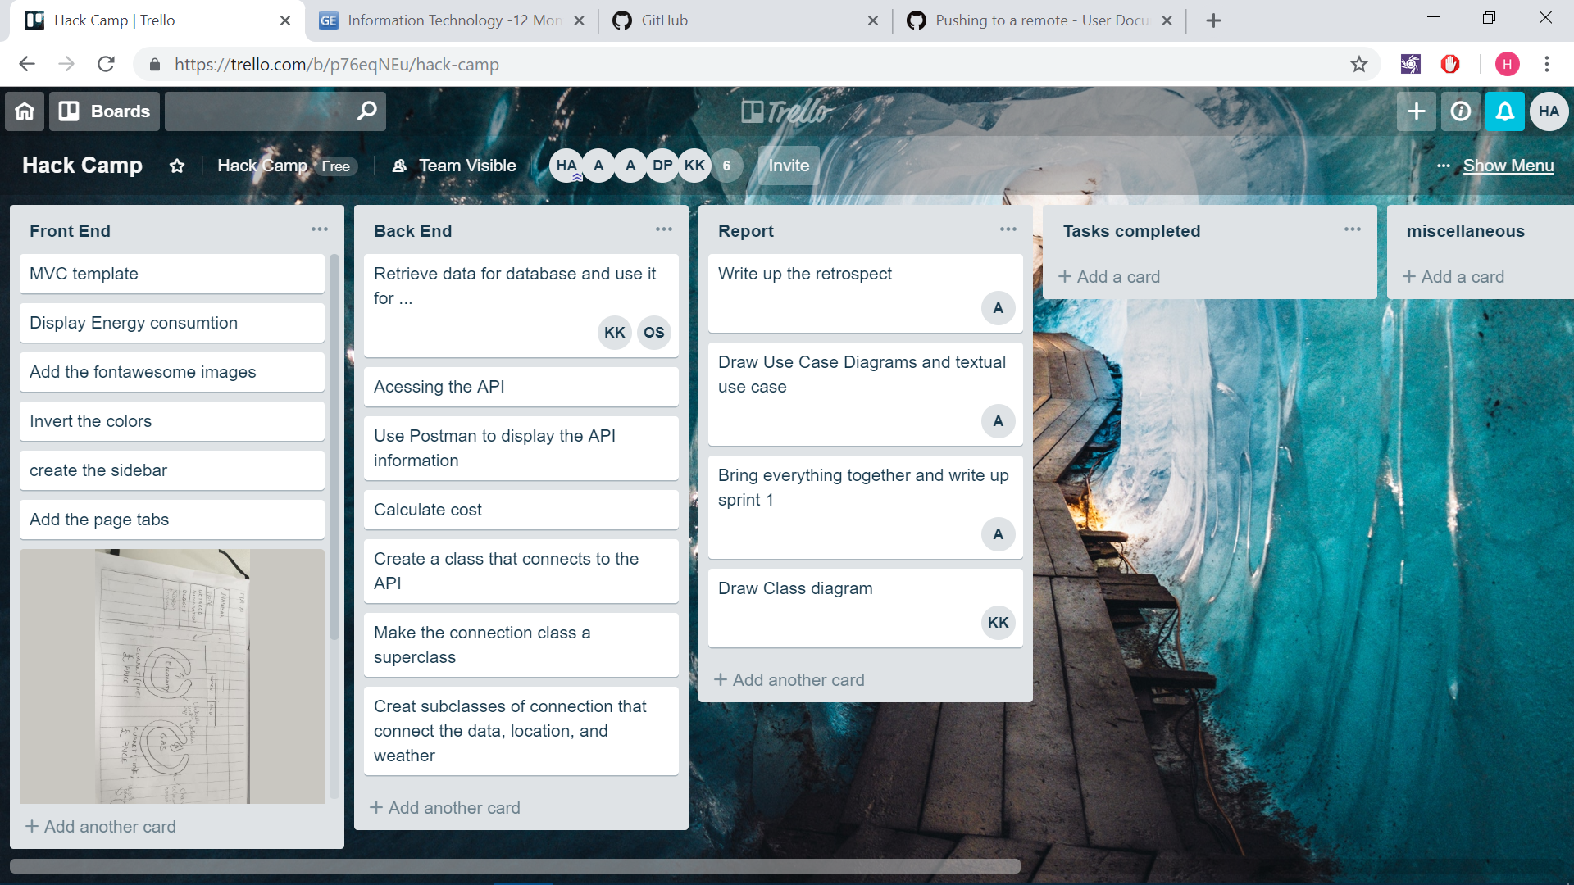

#### End of the sprint

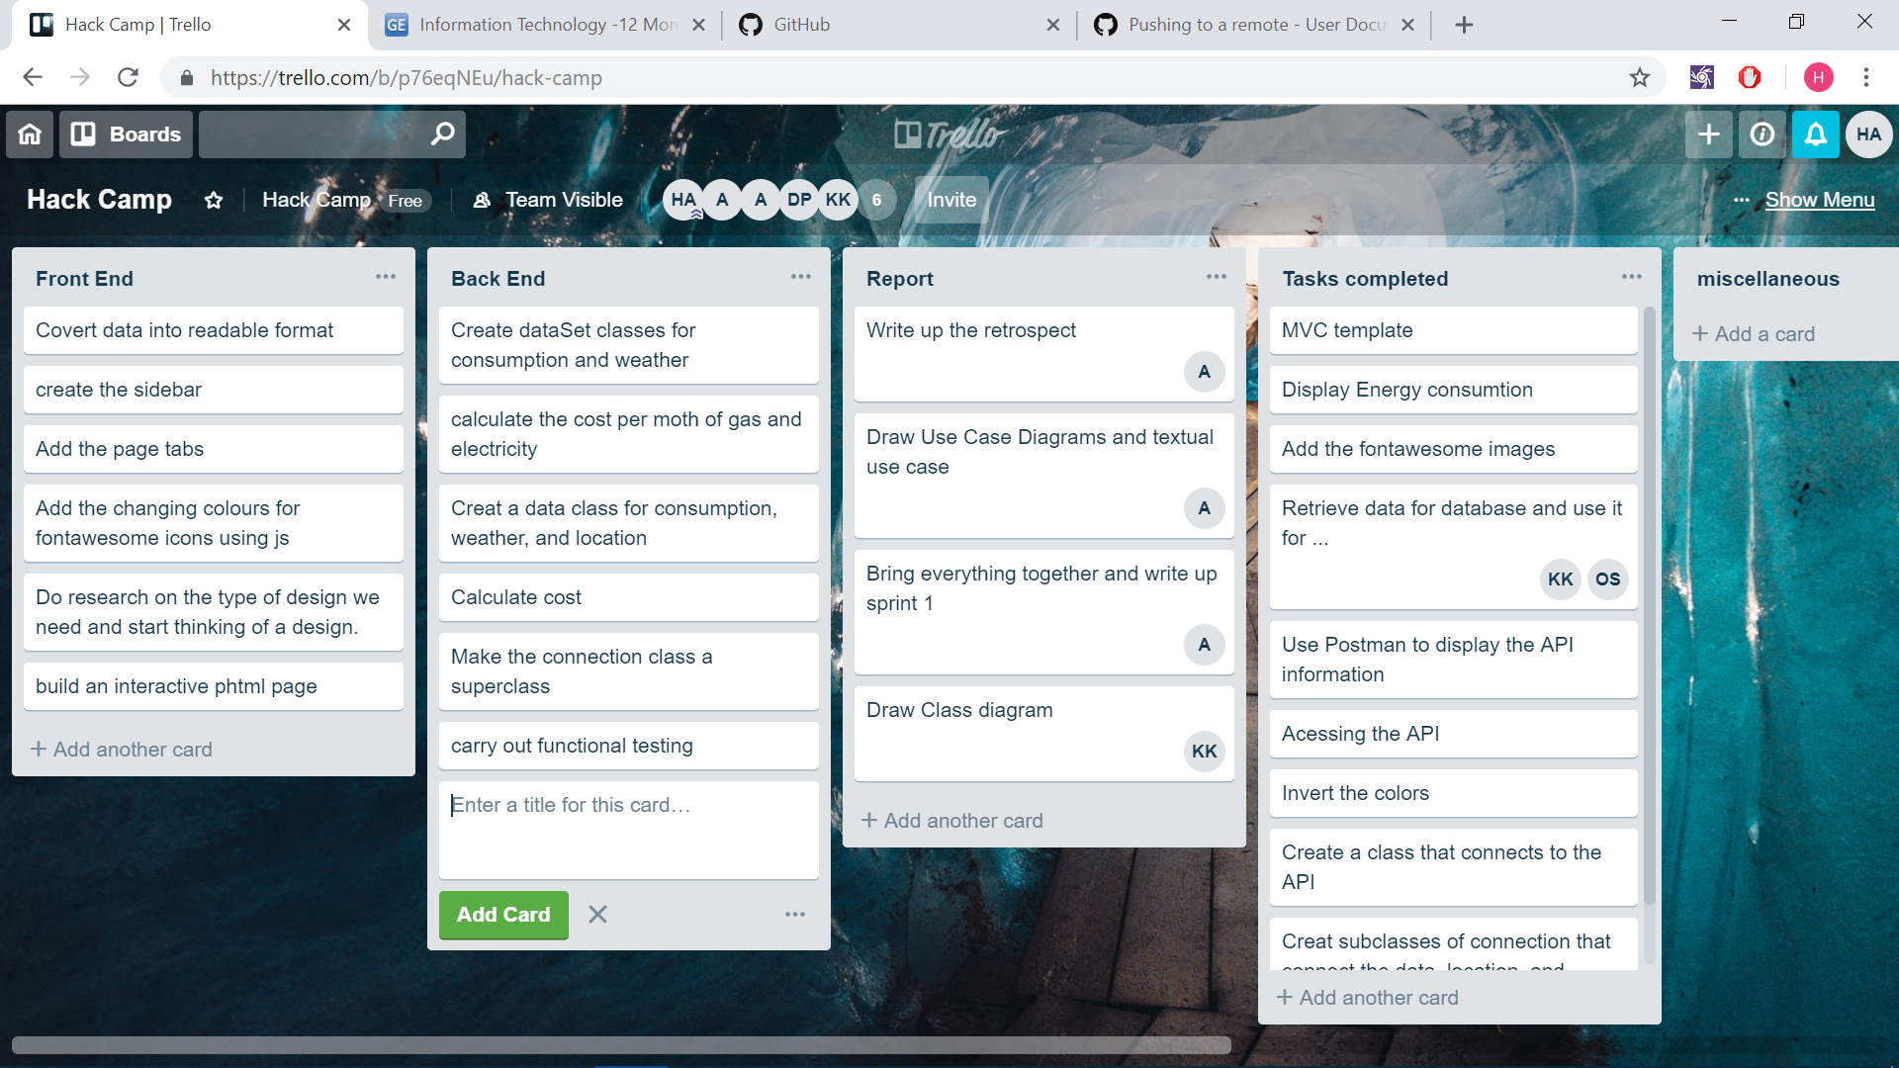

### Assumptions

We found the price we will be using for the cost of electricity and gas. These were split into two parts, night and day tariffs. We assumed that night will be from 00:00 to 07:00 and day will be from 07:01 to 23:59.

We assumed that the client wouldn’t just want to see the kwh on the main screen, but would want to see the budget.

We assumed that the cost would be calculated from the start of the month, rather than the start of the billing date.

### Sprint review meeting (Customer Demo)

The penultimate thing to do in this sprint is the demo with the client in order to demonstrate the features that the group thinks the client wants, get feedback from him and see if the group are on the right track.

During the demo in sprint one, the client was shown several features such as the price of electric and gas for this month which is presented in the home page, the predicted cost of the month which is presented in a sub section of the first page, and a basic chart that represents hourly energy consumption. The design for the price and predicted price was the same where it was two circles like shaped with colors that represented whether the price was low or high. This will be based on a budget that the user sets which is a feature that will be implanted in sprint 2.

The client liked the design the group did for the prices and really liked the idea of the color change and adding a budget. However, the client recommended to work on completing the core requirements before adding these additional features. The client didn’t like the size of the graph and wanted a dynamic graph that shows the hours based on the current time. The final feedback the group got from the client was to add a color legend to the home page that explains to the user what the colors mean. Overall, the client was happy with what he sees and told the group that they are going on the right direction.

Once the demo was over, the group had several questions that were answered, and things were clarified by the client. The data that the group got was from the living room and kitchen of the Joules House. Another thing that was clarified was that the data was 2 minutes behind so that we should be aware of it. The final thing that the client said was, when it comes to the prediction of energy consumption based on weather forecast, the more complex and accurate the solution is, the better. Therefore, in sprint 2, the group will need to do more research and look for some weather prediction API that can be used.

### Sprint retrospective

After the group met with the client and received feedback on the features that were made, the group came together to discuss and reflect on how the first sprint went. The main goal was for each individual to evaluate their performance during the sprint and see what went well and what could be improved. The group as a whole took a few minutes to write some positives and negatives of this sprint on a piece of paper and pass it to someone to write it all on the board. Each member explained why they thought that was the case. Finally, the group wrote down some actions to take to improve the performance of the second sprint.

**Areas for improvement:**

* Objectives were not clear (2 people): After the group went over the requirements and understood what we think the client wants, we broke down the requirements into sections. However, some members said that these tasks were not broken down enough in order for it to be clear and doable so there were times when they didn’t know what to do and just sat there. Therefore, in the second sprint, the team will focus on breaking down the tasks into small, clear, doable actions so that members can work on several of those tasks and know exactly what they are doing for the day.
* Front-end took more time than planned (4 people): Unfortunately, the front-end developers spent a lot of time doing research and lots of different paper designs that not much was done in the first two days. However, the good thing is that the front-end developers themselves acknowledged their short coming and will be working more efficiently from now on. The team decided to focus most of its attention to front-end since most of the back end was already complete. This will allow the team to speed things up by divided the pages and assigning it to people while having a lead front-end developer that oversees everything and works of refactoring the code.
* Front-end knowledge lacking for some front-end developers (2 people): This was one of the reasons why the front end took more time than planned. However, they are still getting used to and learning how to work on the front end. Therefore, this is a learning expensive for them which will make them better and develop their skills. The great thing is that the members didn’t hesitate to ask for help and other members were more than happy to help them. Therefore, the team will do better in the second sprint and this won’t be a problem moving forward.
* Punctuality issues (2 people): This was partly the fault of the entire team since it wasn’t decided upon when the starting time and finishing time was. However, there were one or two members that came later, left early, or didn’t do much work and distracted the others. The group decided to update the code of conduct in order to deal with this issue.
* Planning (4 people): The group was diverse with lots of great ideas and good conversations about which one was good and bad and how they could be improved. However, the group spent too much time talking about new ideas and how to improve existing ones and didn’t spent enough time working on the core requirements that the client wanted. This leads back to objectives not being clear since concrete steps on the core features were not decided upon for the most part. The group did eventually come up with an overall plan on what to show the client and worked on that.

**Positives:**

* Back-end was ahead of schedule (4 people): All members agreed that the back-end developers did great work and nearly completed all the back-end that was needed so display all the information that the user will see. The back-end developers also did great work on retrieving the data from the API and displaying it in PHP using Jason. The code was also well structured with inheritance and static method/variables while at the same time sticking to the MVC template.
* Git was fully functional and well configured: This was a bit of a disagreement between the members in this point. Some members thought that the group was slow when setting up Git and took even longer for all members to understand how it works and use it properly. Other members thought that the configuration of Git was well done, and it was very well understood by most members. The member who ran Git did well and did their best to explain to the other members how it works and how to use it.
* Stand-up meetings: The group had 2 stand-up meetings per day. One was at 11:30 and the other was at 3:00. The first one focused on what each member did yesterday and what they will be working on today and any problems they might be facing or will face. The second stand-up is to see everyone’s progress and to keep track of everyone’s work. The stand-ups were done properly, with all members present, standing and taking 10-20 minutes answering these questions.
* Communication: The team was all good at communicating with each other in a way that was easy to understand. The team also created an environment where asking questions were welcomed and people were getting along well with each other. This made it easy for members to express their ideas, whether it is good or bad, and not be shy and keep it to themselves.
* Report: Since the report was 50% of the project, we decided to start that early and not wait towards the end to write up the whole report which is a good thing. This is beneficial for us since we will be able to recollect event and details that happened a day or two where if we wait till the end of the project, then it will be more difficult to write an in-depth report. The team divided the task of writing the report among themselves. Each person will write a section and by the end of it, the team as whole will come together and do any necessary changes before submitting it.
* Demo: The first demo with the client went really well. Even though we had a slow start and we had some difficulties and problems during the first sprint, the feedback we got from the client was positive and we were given a lot of great feedback. The team will use that feedback to improve the website and work on the next feature in the second sprint and demo it to the client again.
* Balanced team: The team was well balanced. It had 2 amazing front-end developers, a lead developer, 2 back-end developers and a database administrator. These were the main roles; however, the members also did other stuff such as testing, writing reports and other things outside their main role. No one complained with the work they were doing, and most members were okay to do work outside their comfort and expertise in order to speed up any section that was behind.

These were the things that the members thought went well and some things that could’ve been improved upon along with actions to do so. The great thing about this is the honesty that the members showed and self-reflection as a lot of the negatives were self-criticism and lacking areas that members saw in themselves. This shows that the group is self-aware which means that a lot, if not all, of those issues can be resolved in the following sprints.

## sprint 2 (11/01/19 - 14/01/19)

### Sprint Goal

The goal of the second sprint is to show the client additional features of the website which covers the remaining high priority task in the product backlog and get feedback from them. The group will show the comparison page which compares today and yesterday’s energy consumption, the prediction of energy consumption based on weather, and a new version of the home page, which has more details on information about budget, to see which one the client prefers. This will be demoed by 14/01/2019. Since there isn’t much time between the first and second sprint, the goal of this demo isn’t to display perfect fully functional new features but to get an idea into how the user wants it to look and work on that in the third and final sprint.

### Sprint Backlog

In this sprint, the team will decide what they want to show the client. This will be shown in the sprint goal. The team will then choose the user stories in the product backlog that will be used during this sprint. These user stories will be broken down into small tasks that individual members can work on.

|  |  |  |  |
| --- | --- | --- | --- |
| **Backlog Item** | **User Story #** | **Estimated time (hour)** | **Actual Time (hour)** |
| ***As a User, I want to view predicted cost of tomorrow’s energy consumption (Gas & Electric)*** | ***2*** |  |  |
| Research some good weather API to use that will show future weather data. | ***N/A*** | 1 | 2 |
| Get weather data from the API and make it work in PHP. | ***N/A*** | 2 | 4 |
| Use machine learning in order to see which algorithm can best predict the cost based on the information we have. | ***N/A*** | 4 | 8 |
| Change the design and make them a graph. | ***N/A*** | 2 | 2 |
| Build an interactive phtml page that displays the energy cost of both the gas and electric. | ***N/A*** | 2 | 4 |
| Carry out functional testing on this feature. | ***N/A*** | 3 | 3 |
| ***As a user, I want to predict tomorrow's energy consumption through weather forecasting.*** | ***3*** |  |  |
| Use the weather data in the API that was used in prediction of cost. |  | 1 | 2 |
| Use machine learning in order to see which algorithm can best predict the energy usage based on the information we have. | ***N/A*** | 4 | 8 |
| Create a graph design and paper draw how it will look. |  | 4 | 8 |
| Build an interactive phtml page that displays the energy usage of both the gas and electric. | ***N/A*** | 3 | 5 |
| Carry out functional testing on this feature. | ***N/A*** | 4 | 4 |
| ***As a user, I want to compare today's energy consumption with yesterday (Gas & Electric)*** | ***7*** |  |  |
| Get a simple design that will display a comparison of gas and electricity between the two days. | ***N/A*** | 2 | 3 |
| Do some calculation and create functions to display the right energy consumption depending of the two days and their differences. | ***N/A*** | 1 | 2 |
| Build interactive phtml pages that will display the energy consumption of both the gas and electric for the two day. | ***N/A*** | 3 | 5 |
| Carry out functional testing on this feature. | ***N/A*** | 2 | 2 |

### Sprint Plan

This sprint will improve upon some features that was presented on the first sprint, while at the same time adding new features to show to the client. After much discussion and sharing ideas and debating, the team decided to show the client these three features, even though some might have been shown before but has been updated per the clients request and feedback.

1. ***Display the predicted cost of energy for this month (Gas & Electric).***
2. ***Display the prediction of tomorrow's energy consumption through weather forecasting.***
3. ***Display the comparison of today's energy consumption with yesterday (Gas & Electric).***

In order for the team to complete these three features, it had had to be broken down into smaller and more details tasks so that members could work on induvial tasks rather than an entire feature by themselves. The tasks were detailed in the sprint backlog where members could work on the tasks that were there. These tasks were record that in Trello.

The final part of planning was dividing the team so that each member could work on what they are best at. This time however, the team rotated and focused more on front end since the back end was mostly complete. Therefore, we had 4 people working on the front end, 1 or 2 people working on the back end, and 1 person working on testing and making sure everything works fine.

### Trello State

#### Beginning of the sprint

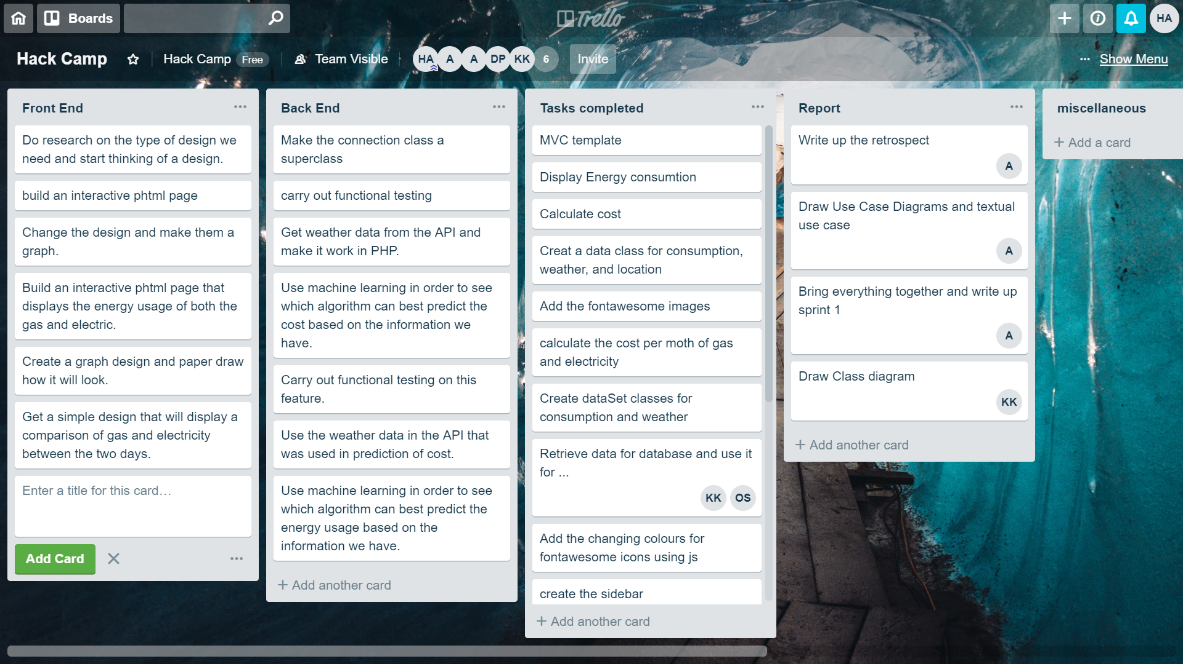

#### End of the sprint

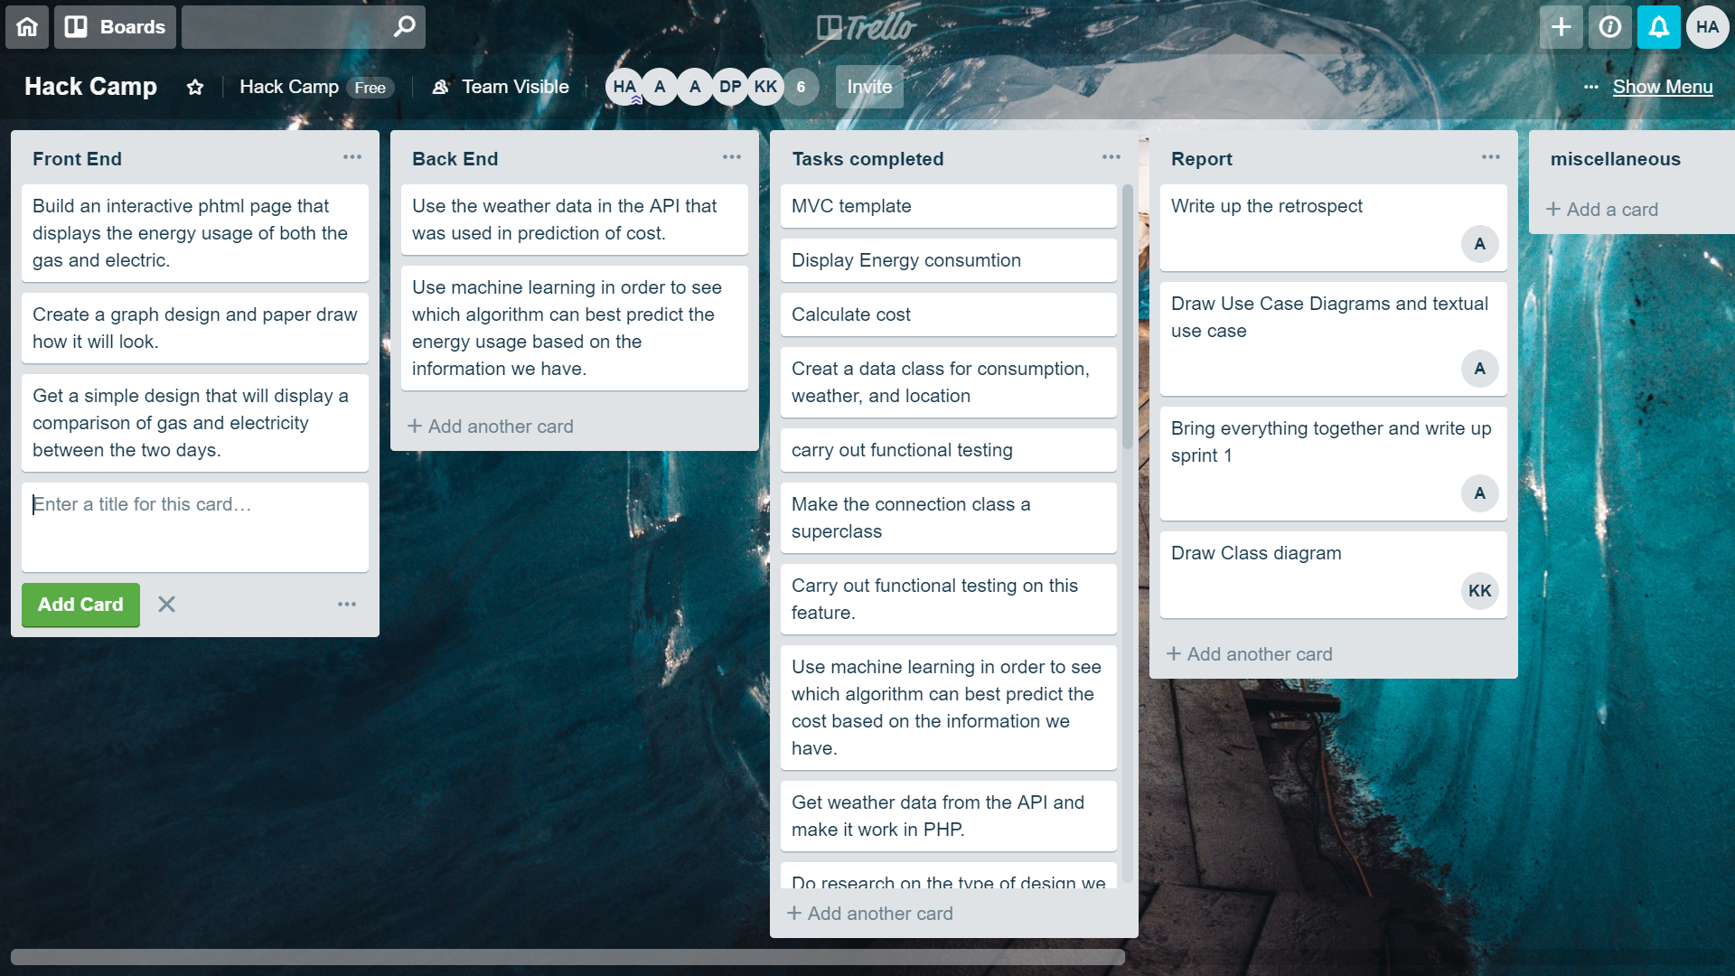

### Assumptions

We assumed that we could get inaccurate location data for the weather prediction API, if we got the location from the IP accessing the website. This would be because, if the IP accessing this data was in a different location to the house, then the data would be inaccurate. We decided to hardcode it.

We assumed that the user would only want to see the usage of the current month in the current year for the electricity and gas, rather than the usage over the previous years.

### Sprint review meeting (Customer Demo)

The penultimate thing the group did during sprint 2 was to have a demo with the client to present the additional features that the group added and to get feedback from him to see if he approves of the changes that the team made.

In the demo, the client was shown the three new/updated features. Those features were; for the user to see the predicted cost of energy consumption of both gas and electric, for the user to see the prediction of tomorrows energy consumption through weather forecast, and to see the comparison of today and yesterday’s energy consumption of both gas and electric.

During the demo, the client didn’t like the design of the comparison page and wanted to make it a graph so it would be easier for the user to understand. Another thing the client pointed out was to round numbers up to make it easier to read when you don’t have 7 decimal places. The final thing the client didn’t like was the color switch for color blind people. The group was told to do some research on color blindness and add a feature that will help them view the colors or make it easier for them to use. This would need to be done in sprint 3.

The group showed the client two different version of the home page that showed the cost of gas and electric and wanted to get his feedback on it. The client liked both designs and wanted to have both in the website. He also wanted us to have a page that showed the instantaneous energy consumption so the group would need to work on that I sprint 3. An additional feature the client said that could be added would be to have a customized graph for comparison that allows the user to pick the times that they want to compare with. This will give them the option to compare days, weeks or months. A further enhancement to that extra feature would be to let the user choose any time period and any day/week/month to compare.

Overall, the feedback the group got was helpful and gave the group an idea of how to move forward and what changes need to be made in order for it to agree with what the client wants.

### Sprint retrospective

After the group met with the client and received feedback on the features that were made, the group came together to discuss and reflect on how the first sprint went. Each member answered 3 questions:

1. What went well in this sprint (positives)?
2. What went wrong (negatives)?
3. How could this sprint be improved/ What can we do to make the next sprint better?

The group wrote down their thoughts on the board and talked about each point in order to improve the performance of the second sprint.

**Areas for improvement:**

* Not much communication from certain members: since this sprint was mostly over the weekend, the main source of communication between the team was online using WhatsApp. Some members didn’t join the conversation at all which other members didn’t like since it made them do more work due to them being non-responsive. However, one of the reasons why this was the case was because, at times, there will be 100+ messages in a short span of time that will be talking about the project and what they are doing which some members will not bother to read.
* Database aspect of the system took too long: even though we only used one table in the database, setting up the server and database took longer than expected. This was partly due to waiting for the School to give us a helios account and partly due to the person working on it taking one to two days to set up the table.
* Incorporating the implementation of colour blindness: after the demo with the client, the group was made aware of how important the issue of accessibility which the group forget to think about during the planning phase. Therefore, the group will incorporate it in the 3rd sprint.

**Positives:**

* Meeting an completing all the core requirements: the group was able to complete all the requirements that the client wanted and was demoed to him. The client was happy with most of what he saw and the few things he liked will be updated and shown to him in the demo of the third sprint.
* Extra features were adding while at the same time completing the core requirements: the group was able to complete the main requirements that the client wanted and started to work on adding additional features to the project. Some of the additional features that was and will be added is he budget were a user can set a budget and get alerts when the users reaches the budget they set. Another thing the group did was work on enhancing the features that were requirement and adding more functionality to it. These were reviewed and explained to the client which he liked and approves of.
* Refactoring: the group worked on having a cleaner code which is easier to understand and speeds up the process by making it more efficient. The group also added a lot of comments to the code to make sure that everyone in the group and anyone that looked at our code understood what was going with the code once they look at it.

Things to do in sprint 3:

* Set working hours and entry times: due to the fact that some members were coming late and leaving early, the group agreed on working 5 hours a day minimum. This will be mainly dictated by each member. However, all members must be in the room 149 between 10 and 11 since the stand ups begin at 11am.
* Work on adding everyone to the conversation: some members are not active when it comes to making decisions and discussing any issue. Therefore, the group decided to actively work on talking directly to those people and get their opinion in matters in order to get them to join the conversation.
* Assign more people to the database in order to get it complete: since the person that was assigned the database was taking longer than expected due to it being harder to set up, an extra member will be added to this task in order to get it complete at the beginning of sprint 3.
* Research on colour blindness: the group will need to do a proper research on colour blindness and find out the different types and what is best for each one. This will then allow us to choose the colours that will work best for most, if not all types of colour blindness.

## sprint 3(14/01/19 - 18/01/19)

### Sprint Goal

The goal of the final sprint is to show the client the final website with all the features planned in the product backlog and get a final feedback from them. The group will work on to improve the comparison page with the feedback received from the client in the last demo. Add the new ‘Cost based on Chart’ feature to the homepage. Add the instantaneous feature to the website. General HTML, CSS and JavaScript refactoring and cleaning of the code. All this will be demoed on the 18th of January. With a whole week ahead of us the goal is to have a fully working website which meets all the customer requirements and beyond.

### Sprint Backlog

The group will choose the user stories in the product backlog that will be used during this sprint. These user stories will be broken down into small tasks that individual members can work on.

|  |  |  |  |
| --- | --- | --- | --- |
| **Backlog Item** | **User Story #** | **Estimated time (hour)** | **Actual Time (hour)** |
| ***As a user, I want to compare today's energy consumption with yesterday (Gas & Electric)*** | ***7*** |  |  |
| Create bar Charts with hard coded values | ***N/A*** | 3 | 4 |
| Create functions for each one of the charts | ***N/A*** | 4 | 8 |
| Once needed data has been retrieved. Replace hard-coded values with actual data | ***N/A*** | 2 | 3 |
| Carry out functional testing on this feature. |  | 4 | 4 |
| ***As a user, I want to have an option to set a budget for how much I spend on energy.*** | ***4*** |  |  |
| Find the right Chart that will help the user to easily understand the displayed information | ***N/A*** | 4 | 4 |
| Create a graph design and paper draw how it will look. | ***N/A*** | 1 | 2 |
| Customise the chart to our needs with hard coded value. | ***N/A*** | 2 | 1 |
| Build an interactive phtml page that displays the charts for both the gas and electricity | ***N/A*** | 2 | 3 |
| Retrieve the required data with the already created encapsulated function and send them display them on the charts | ***N/A*** | 1 | 0.30 |
| Carry out functional testing on this feature. | ***N/A*** | 4 | 5 |
| ***As a user, I want to view the instantaneous energy consumption (Gas & Electric)*** | ***5*** |  |  |
| Discuss and decide on how we want to display this information | ***N/A*** | 4 | 5 |
| Create a design on how the display is going to look like | ***N/A*** | 2 | 2 |
| Create a dynamic display using JavaScript and HTML following the client guidelines with hard-coded values at first | ***N/A*** | 5 | 7 |
| Replace the hard-coded values with the real-time data | ***N/A*** | 2 | 2 |
| Carry out functional testing on this feature. | ***N/A*** | 5 | 5 |

### Sprint Plan

The sprint will help us reach our finished product, ready to be presented and delivered. It will help us improve all the already present features and add some extra ones too. The key feature for our last demo to be presented to the client are going to be:

1. Improved Display of comparison page
2. Instantaneous Consumption
3. Display the cost based on Budget

Another task is the refactoring of the code. Working for the first time on as a group had his up and downs, such as repetition of code and unused lines of code. Therefore, we decided to make sure the code gets looked at it one more time before the CODE FREEZE.

The Key features have been broken down into smaller and more detailed tasks, so that each member could work on an individual task and to the whole feature by himself. Task were also added to Trello to help everyone have access to a visual list of all the task that needed to be done by Friday 18th of January.

We followed the same group division used in Sprint 2, where the majority of the group worked on the front-end and the remaining few on improving the back-end, at rotation we also had always someone that focused on testing that every single change/feature added to the master was fully working and not conflicting with the rest.

### Trello State

#### Beginning of the sprint

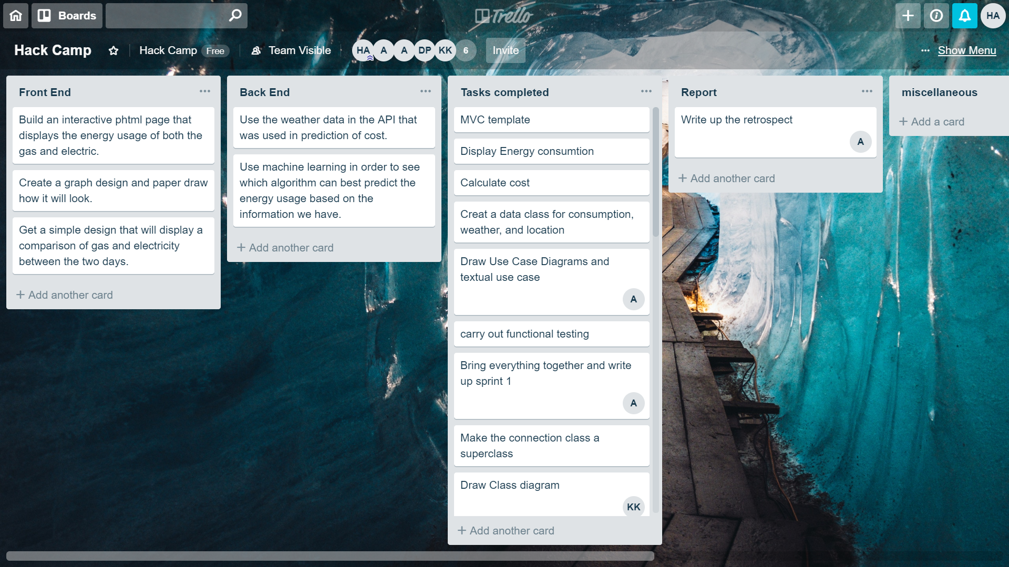

#### Middle of the sprint

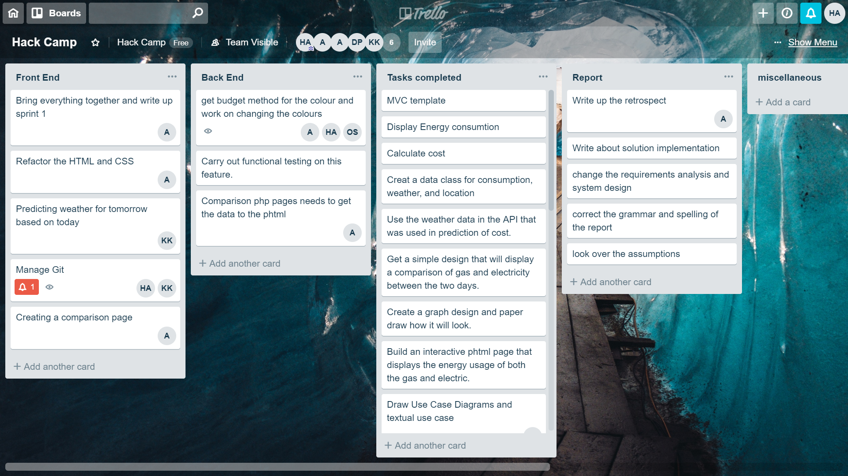

#### End of the sprint

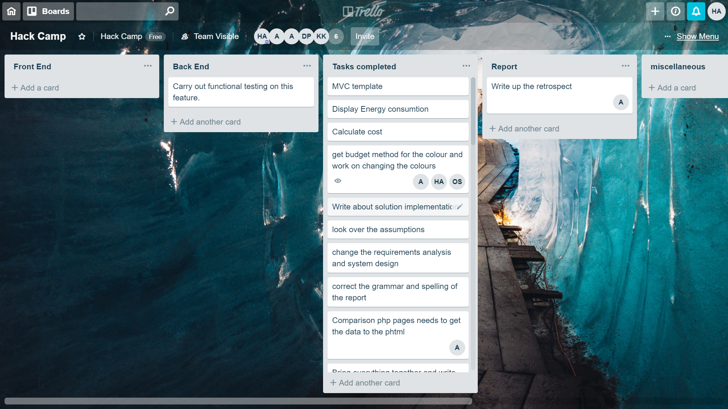

### Assumptions

We assumed that the user wouldn’t want to see a static image for the instantaneous consummation speedometer, that updates every minute. We decided to let the number update within a range every second, to make it seem faster than it is.

### Sprint review meeting (Customer Demo)

On the 18th of January, we had our last Demo with our client. We already had a CODE FREEZE set. Therefore, any major change would not have been possible due to the time limit.

In the Demo, the client was shown the final product with all the improvements and new features.

This time, the client was happy with how we designed the comparison page by following his guidelines by using a bar chart. Overall, he was satisfied that all the requirements have been met and also extra features have also been added to the product.

No major changes were needed in his opinion, only few small design changes to make the website more appealing and easily usable by any user.

Overall, the feedback was very good. This helped bring the group morale up by being able to meet set requirements and deadline and be able to than focus on the power point presentation and the remaining parts of the report.

### Sprint retrospective

After our Demo, the group came together to discuss and reflect on how the last sprint went. This time the team only answered 2 question were answered:

1. What went well in this sprint(positives)?
2. What went wrong (negatives)?

(no discussion on improvement on next sprint since this was our last one)

We all gathered around a board and started writing down all the answers and discuss each one of them.

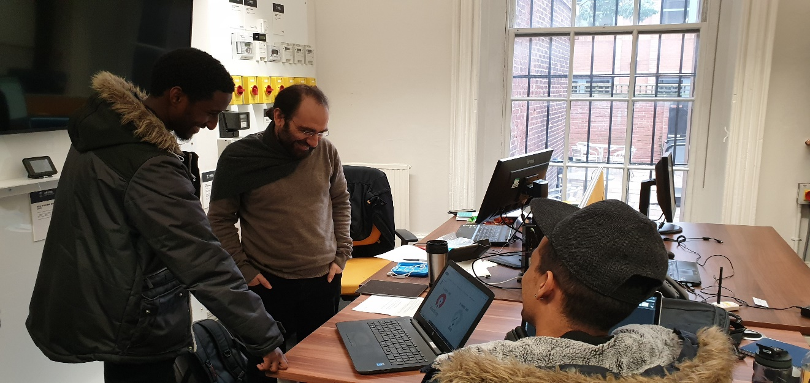

**Areas for improvement:**

* Report and Power point presentation were behind with what has been planned. We gave too much priority to the code itself. This is not due because of any particular member of the group, simply a lesson we learned by working for the first time together. After talking about it we realised that we spent too much time changing stuff that did not need it rather than focus on more important task such as keeping up the report with the work done.
* During refactoring, some members of the group brought some major changes to the whole structure of the code without leaving any comments, making it harder for the rest of the group to follow what has been changed. The changes applied were all good, the issue simply has been that there has been a lack of communications between the group when this amends have been applied.
* Scraped email feature. This was an extra feature we wanted to add to our website. Unfortunately, we struggled hosting the website live and spend too much time behind it. We ended up having not enough time to develop it further therefore, we decided to not implement the feature but have n alert to let the user know that they reached their budget limit.

**Positives:**

* Refactoring, other than be a negative aspect of this sprint we also added it to the positive ones. We managed to encapsulate many functions and get rid of a lot of unused code that had been added at the beginning of the project.
* We all agreed that we worked well together as a team, even if we had various technical conflicts, because at the end of the sprint 3 we were able to meet most if not all the set deadlines and meet all the client’s requirements.
* This sprint has also been planned in a better manner compared to the previous 2, and this helped us a lot during the whole process of getting every task completed within time.
* A lot of members put a lot of efforts during this sprint and invested a lot of extra working hours on their task outside the daily 5 hours of commitment we all agreed to.

Finally, we were happy about our teamwork, we improved a lot compared to our first sprint where we had a slow start due to lack in planning and also to members from different team being able to help other members who were struggling in their tasks making sure everyone met their deadline.

# Requirements analysis and system design

### System Architecture

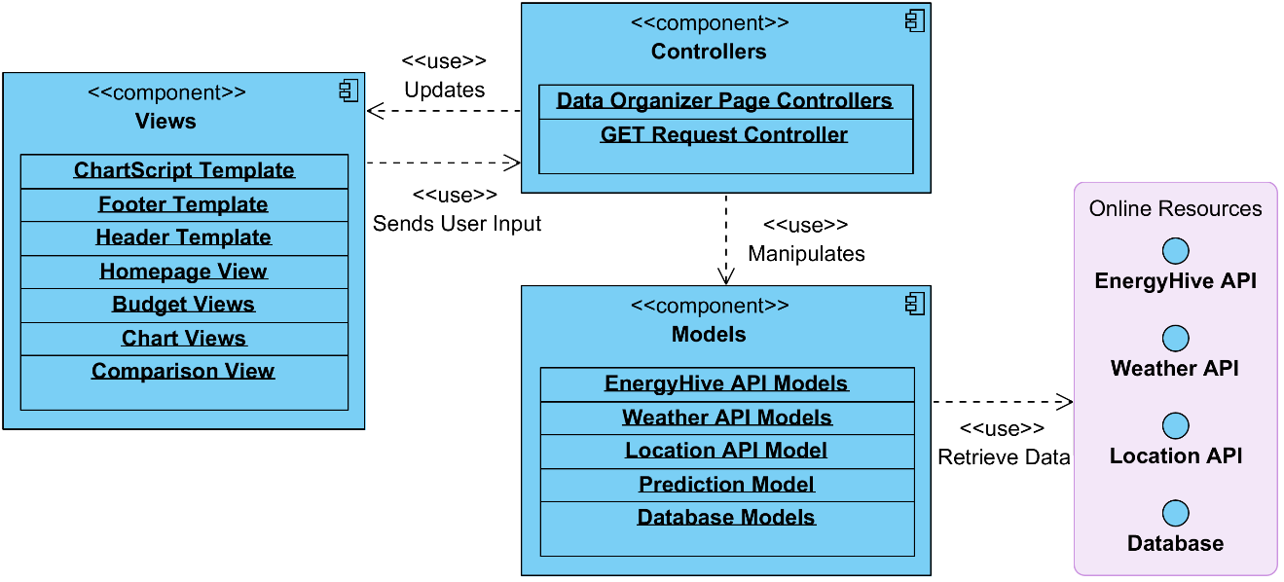

For the project, the Model View Controller (MVC) software architecture pattern was followed, as the group opted to develop the project as a Web Application.

The MVC, as stated on MDN Web Docs, is a design pattern that separates the application logic into three separate parts to promote modularity, ease of collaboration and reuse (MVC architecture, 2018). The Models defines what data the app should contain, the View defines how that data is displayed to the user, while the Controller contains code that updates the Model and/or the Views in relation to the input from the user (MVC architecture, 2018).

Using the MVC pattern in the team proved to be particularly useful, as the group were able to separate the members of the team into two separates groups, one working on the back end, while the other working on the front end and neither of them had to stress too much about what the other group was doing as the two parts where close to independent.

### database design

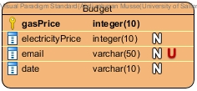

The reason why a database is needed is because certain information that the user enters needs to be stored permanently or at least appear when the user closes the browser. The information the users fills in is the budget they wish to set for their gas and electricity.

The budget table is used in the setBudget and seeBudget page. In the website the user sets their electricity and gas budget. In order to do so, the user enters a price for both the gas and electricity and that will be stored in the database under the gasPrice and electricityPrice fields. Along with setting the budget, the user also must select the billing date of electric and gas. This will also be stored in the database under date field. The email field in the database is used to check if the user has already set a budget. If the budget is already set, then the old budget will be updated instead of inserting a new budget in the database.

Helios is used to create the database. In the database file, PDO was used to make a connection to the Helios database. The PDO “conn” variable contains a username and a password. These two are the Helios account username and password. Once that is set, the connection is established, and PHP can be used to manipulate the database and retrieve data.

### Product backlog

The table below is the product backlog which contains the things that needs to be done within the project.  A few of them is selected during each sprint and broken down to become a sprint backlog (Bass J. , Salford, n.d.). At the end of the project, each one of these user stories must be met. The priority is set by the client and the backlog items might change as the project goes on.

|  |  |  |  |  |
| --- | --- | --- | --- | --- |
| **User Story** | **Backlog Item** | **Estimated time** | **Actual Time** | **Priority** |
| **1** | As a user, I want to view my energy cost so far for this month (Gas & Electric). | 1d | 1d 1h | High |
| **2** | As a User, I want to view predicted cost of tomorrow’s energy consumption (Gas & Electric). | 2d | 1d 12h | Medium |
| **3** | As a user, I want to predict tomorrow's energy consumption through weather forecasting. | 2d | 1d 3h | High |
| **4** | As a user, I want to have an option to set a budget for how much I spend on energy. | 1d | 15.5h | Low |
| **5** | As a user, I want to view the instantaneous energy consumption (Gas & Electric) | 1d | 21h | High |
| **6** | As a user, I want to view energy consumption of gas & electric per hour/day/week/month. | 1d | 14h | High |
| **7** | As a user, I want to compare today's energy consumption with yesterday (Gas & Electric) | 1d | 1d 7h | High |

### Use Case Diagram

As shown in the diagram below, we have a single primary actor which is the user of the website. This is shown on the left-hand side of the diagram. There are no secondary actors present in the system (Bass J. , n.d.). The box in the middle represents the Smart Meter Smart Home system and the actions that take place within the system. The basic structure was found on lucidchart along with lots of useful information about use cases (2018).

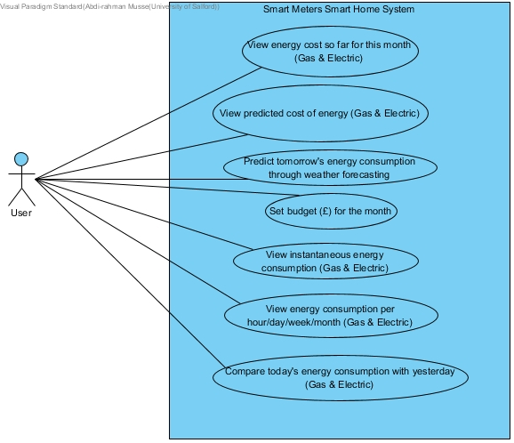

### Textual Use Case

|  |  |
| --- | --- |
| **Use case title** | **View energy cost so far for this month (Gas & Electric)** |
| **Primary actors** | User |
| **Goal** | For the user to see the amount of money they have to pay so far for this month. |
| **Scope** | Smart Meters Smart Home System |
| **Precondition** |  |
| **Post-condition** | User will be informed of how much they spent on gas and electricity from the beginning of the billing date till now. |
| **Main success Scenario** | 1. Go to the website 2. Go to home page (if you are not already there) |
| **Extensions** | 1.a Website can’t be accessed |

|  |  |
| --- | --- |
| **Use case title** | **View predicted cost of energy (Gas & Electric)** |
| **Primary actors** | User |
| **Goal** | For the user to get an idea of how much he will pay in the next couple of days. |
| **Scope** | Smart Meters Smart Home System |
| **Precondition** | 1. The user has been using the smart meter for more than a day (price is based on history & current usage). |
| **Post-condition** | User will be given an estimation of how much he has to pay in the next few days. |
| **Main success Scenario** | 1. Go to website 2. Go to home page (if you are not already there) 3. Click on predicted cost in the home page |
| **Extensions** | 1.a Website can’t be accessed  3.a Prediction option isn’t there |

|  |  |
| --- | --- |
| **Use case title** | **Predict tomorrow's energy consumption through weather forecasting** |
| **Primary actors** | User |
| **Goal** | For the user to see the predicted energy comparison of tomorrow |
| **Scope** | Smart Meters Smart Home System |
| **Precondition** |  |
| **Post-condition** | The user can see how much energy he will spend tomorrow on gas and electricity (estimate) |
| **Main success Scenario** | 1. Go to the website 2. Go to home page (if you are not already there) 3. Click on the predicted usage in the home page |
| **Extensions** | 1.a Website can’t be accessed  3.a Prediction option isn’t there |

|  |  |
| --- | --- |
| **Use case title** | **Set budget (£) for the month** |
| **Primary actors** | User |
| **Goal** | For the user to set a budget to better manage how much they pay per month |
| **Scope** | Smart Meters Smart Home System |
| **Precondition** |  |
| **Post-condition** | 1. The user has set a budget on both gas & electricity which will be shown by viewing cost in home page |
| **Main success Scenario** | 1. Go to the website 2. Click on the menu bar 3. Click on set budget option 4. Set budget for gas and electricity |
| **Extensions** | 1.a Website can’t be accessed  2.a Menu is missing  3.a Budget option isn’t there  4.a User set budget for the wrong type of energy |

|  |  |
| --- | --- |
| **Use case title** | **View instantaneous energy consumption (Gas & Electric)** |
| **Primary actors** | User |
| **Goal** | For the user to view their instantaneous energy consumption of both gas and electricity |
| **Scope** | Smart Meters Smart Home System |
| **Precondition** |  |
| **Post-condition** | User will be shown their instantaneous energy consumption of both gas and electricity |
| **Main success Scenario** | 1. Go to the website 2. Go to home page (if you are not already there) 3. Click on instant consumption in the home page |
| **Extensions** | 1.a Website can’t be accessed  3.a Instant consumption option isn’t there |

|  |  |
| --- | --- |
| **Use case title** | **View energy consumption per hour/day/week/month (Gas & Electric)** |
| **Primary actors** | User |
| **Goal** | For the user to view their energy consumption of a given time period (hours, days, weeks, months) |
| **Scope** | Smart Meters Smart Home System |
| **Precondition** | 1. For the smart meter to have been installed before the period that the user wants to see. (e.g. must be used for at least a week if user wants to see monthly consumption) |
| **Post-condition** | User will be shown their energy consumption of a given time period (hours, days, weeks, months) |
| **Main success Scenario** | 1. Go to the website 2. Click on the menu bar 3. Go to charts option 4. Click on the period you want to view |
| **Extensions** | 1.a Website can’t be accessed  2.a Menu is missing  3. Chart option isn’t there  4. User chooses the wrong time period |

|  |  |
| --- | --- |
| **Use case title** | **Compare today's energy consumption with yesterday (Gas & Electric)** |
| **Primary actors** | User |
| **Goal** | For the user to see the comparison between today and yesterday’s energy consumption |
| **Scope** | Smart Meters Smart Home System |
| **Precondition** | 1. For the user to have used the smart meter for more than 1 day |
| **Post-condition** | The user can see a visual comparison of the energy consumption of today and yesterday. |
| **Main success Scenario** | 1. Go to the website 2. Click on the menu bar 3. Click on the comparison option |
| **Extensions** | 1.a Website can’t be accessed  2.a Menu is missing  3.a Comparison option isn’t there |

### Class Diagram

Some reseach was done regarding the genernal strucutre of class diagrams (Bass, n.d.) and mulitplity (Bell, 2004).

The class diagram represents:

* Connecting to three API's
* Getting the data from the API's
* Storing the data obtained into relevant objects
* Performing calculations on the data retrieved
* Prediction on consumption based on training data stored for 4 months (September- December)
* Connecting to a database
* Retrieving and storing information in tables
* Reading data from files stored in the system

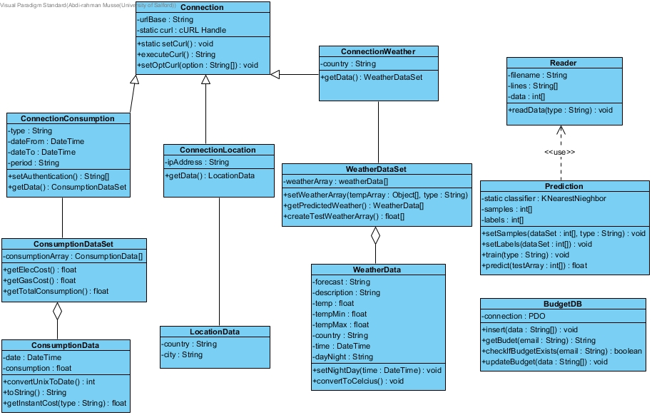

# Description of the solution implementation

To provide a solution to the client a wide variety of software were used. These can be mainly classified into the following groups:

**Development (To develop the smart meter display)**

* PHP Strom
* Atom
* My SQL
* GitHub along with VCS for PHP Storm
* Composer

**Documentation (To document and record events and information)**

* Trello
* Microsoft Word

**Testing (To validate the html and CSS and verify the authenticity of the data)**

* Postman
* CSS and HTML Validators

Communication (To relay information regarding meetings and daily tasks)

* Microsoft Outlook
* WhatsApp Group
* GitHub

## Setting up back-end classes and getting data from the API for PHP (Kumail Kamran)

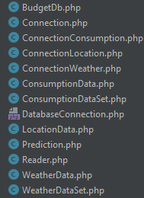 

**Fig 1.1 Showing the class structure**

Classes were setup to extract data from the API. Inheritance and static instances were considered in order make the extraction as efficient as possible. This is shown figure 1.1.

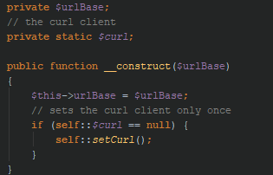

**Fig 1.2 showing code from the Conncetion.php class**

The constructor initializes the curl client only once because it is needed only once and can be used as many times on the same page as needed. This is shown figure 1.2.

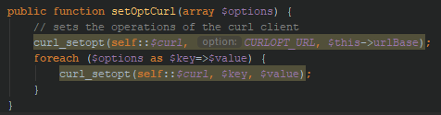

**Fig 1.3 showing code from the Conncetion.php class**

The code in figure 1.3 sets the options for the curl client and to set many options at once all the options need to be passed to an array. The URL option is always required to be set to the curl client. That is why it is the only one which is always set when the method is called.

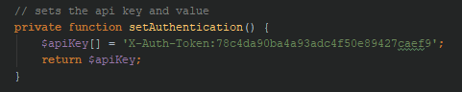

**Fig 1.4 showing code from the ConnectionConsumption.php class**

The code in figure 1.4 is specific to different API’s since different API’s tackle security differently.

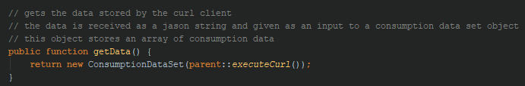

**Fig 1.5 showing code form the ConnectionConsumption.php class**

The code in figure 1.5 takes the data stored by the API and converts it to a ConsumptionDataSet object. This section of the code is repeated for the rest of the classes that inherit from the Connection class and the data is converted into their respective collection objects.

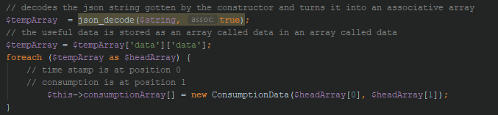

**Fig 1.6 showing code from the ConnectionDataSet.php class**

The code in figure 1.6 deals with the data that comes in JSON format from the API and then converts it into consumption data objects stored inside a consumption data set array, this is also done for the rest of the collection classes that take data from their respective API’s

## Getting data from a training set and setting up the K-NN prediction algorithm (Kumail Kamran)

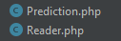

**Fig 2.1 showing class structure for the prediction aspect of the system**

Two classes were setup for the purpose of predicting which is shown in figure 2.1. The reader class would read the data from the training files and the prediction class would make use of that training data and then make a prediction based on the next day’s weather forecast.

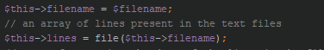

**Fig 2.2 showing code from Reader.php class**

The code shown in figure 2.2 allows for the data to be converted into an array of lines and stored for further use.

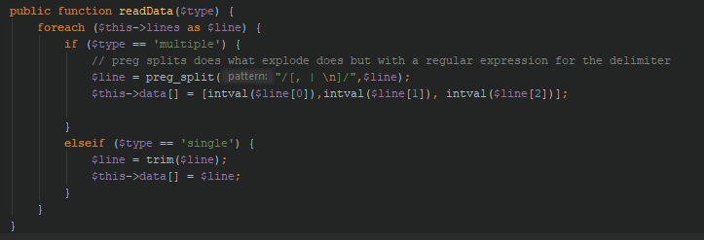

**Fig 2.3 showing code from the Reader.php class**

The code in figure 2.3 allows for the data stored on the individual lines based on the type of data (single or multiple based on the delimiter ‘,’) to be read, converted into a format that is readable for the prediction algorithm, and then stored into a data array.

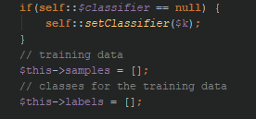

**Fig 2.4 showing code from the Prediction.php class**

The code in figure 2.4 allows for only a single classifier (a class that allows the group to use the K-NN algorithm) to be used in the page. The samples are where the training data is stored, and this is done with the exclusion of the class value (value to be predicted). The classifier takes a parameter K which specifies how many nearest points need to be used to reach a decision.

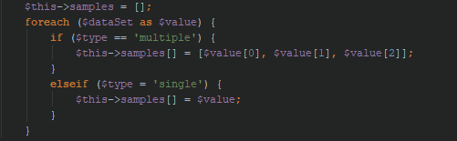

**Fig 2.5 showing code from the Prediction.php class**

The code in figure 2.5 sets the samples to be used by the classifier based on the type of data it is provided with (single or multiple based on the delimiter ‘,’). The code for setting the labels (class values for the samples) is like the else part of the statement.

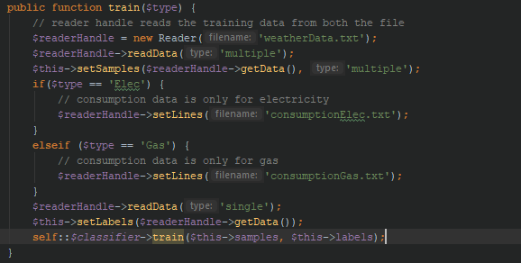

**Fig 2.6 showing code from the Prediction.php class**

The code in figure 2.6 trains the classifier on the samples and labels that it has stored. This training is done based on which type of data the classifier has been asked to predict and can have one of two values (Electricity or Gas).

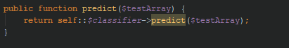

**Fig 2.7 showing code from the Prediction.php class**

The code in part 2.7 predicts the value based on previous training data stored by the classifier. The test values are given to this classifier are stored in an array.

## Comparing Electric and Gas Usages (Abdi Rahman Musse)

The controller page’s job is to get data and information from the Model and pass it to the view. This page gets information which is used to display the comparison of energy consumption of both electricity and gas. To do this, a ConnectionConsumption object is created which is a sub class of the Connection class. This establishes the connection to the API.

The constructor of the ConnectionConsumption class requires three parameters as shown in figure 3.1. These are; the type of energy you want (gas or electric), the start time stamp of the data you want to get, and the end time stamp of the data you want to get. Once the class is created, it calls the getData() method which creates a ConsumptionDataSet class. This is where the data of the API is processed and stored appropriately.

Now that the everything is established, there are methods in the ConsumptionDataSet class that allows you to retrieve the data that you might need by looping through the array that holds the data with the energy consumption. The getTotalConsumption method is called in this case which retrieves the total energy consumption that is specified in the parameters. All this is stored in a function which is used repeatedly by simply changing the parameters in the function to get different energy consumptions of different times.

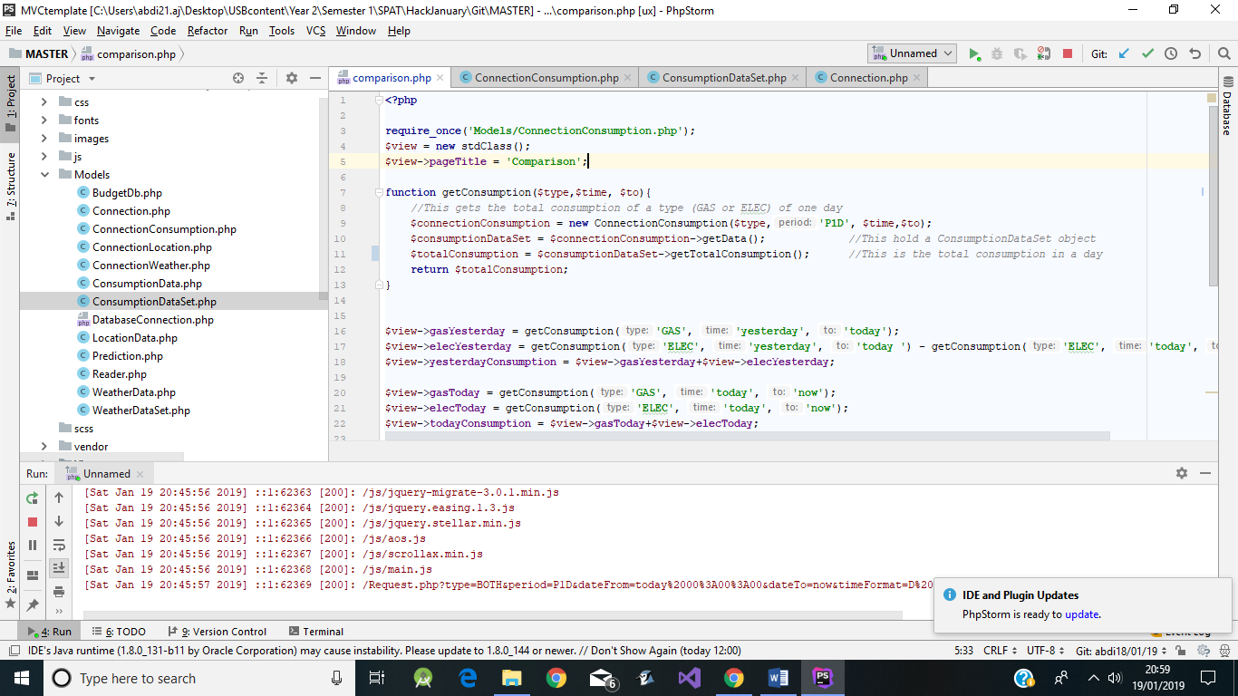

**Fig 3.1 showing code from comparison.php**

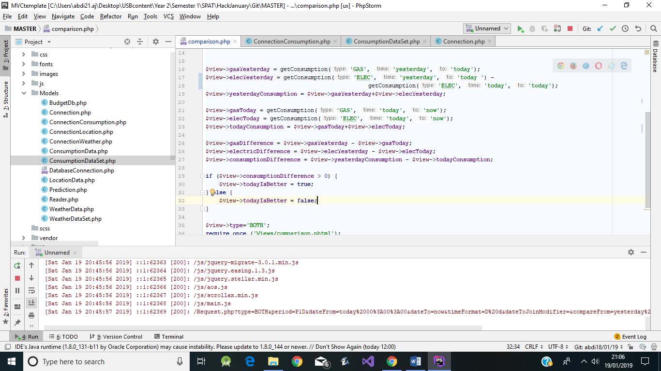

**Fig 3.2 showing code from comparison.php**

## Google Bar Charts for displaying consumption (Davide Pozzoni)

The bar charts can be found on the Homepage under Predicted cost, consumption, under the Comparison page and the pages for electricity and gas usage. All those charts are created using Google Charts (Bar Charts, n.d.).

Google Charts is a free chart representation tool provided for free by Google. It uses HTML5 and JavaScript, making it compatible with all modern platforms. It is quite limited in some regards, while it offers a wide variety of graphical representation of data (Bar Charts, n.d.).

For the use that was needed, the group opted for the bar chart. That tool uses three main parts to work, a call to load the chart libraries, a function that defines the data and the style of the chart, and a onload call that is passed the defining function and it is responsible for drawing the chart on the screen (Bar Charts, n.d.).

The function that defines the chart is composed of three variables. The main one is the Data variable, responsible for storing and organizing the data that needs to be shown in the chart. It is an array of arrays, with the first index containing the definition of the type of data. The second is the Style variable, that is an array containing a set of variables that defines the look of the chart. Finally, the last is the Chart variable that holds the Google Chart object, that is passed the HTML element where the chart needs to be drawn, together with the two previously mentioned variables (Bar Charts, n.d.).

The main limiting factor of using Google Charts is the Google onload function that is necessary for the charts to be drawn on the screen. That function does not officially allow to have parameterization, forcing to have repetition of code to be able to draw more than one chart. However, being a quite popular tool, the community was able to discover and work around that problem; by creating a new function inside the onload call, then that function can be defined as a call to a function that can then be parameterized. That workaround was used together with jQuery HTTP GET functions (See *Http Get and Request Controller*) to completely avoid repetition of code and to keep coupling to a minimum (Bar Charts, n.d.).

## Instantaneous Consumption (Davide Pozzoni)

To represent the instant consumption, the group opted for an independently created tool, called gauge.js which was coded by Bernard Kobos (Kobos, n.d.).

Gauge.js is a JavaScript chart that is simple looking, while being highly customizable and able to be updated with new data at any time. That tool was chosen over other especially for those reason that we added the instant consumption when the rest of the design was already finalized. Therefore, we needed something that would fit well with simplicity of our design, while being intuitive and easy to use for the user (Kobos, n.d.).

While having the user in mind, the group challenged themselves to use a solution that was harder to use than other possible alternatives. That is because the tool that was used lacked proper documentation. While the tool and the author deserve to be praised, the lack of documentation poses an unnecessary obstacle, that not only makes the tool harder to use, but even hides many of the useful features. One example of that is the function we’ve used to set the color of the icon under the gauge to be the same as the one currently used by it. This feature is not advertised anywhere. To discover and use it the group had to explore the code by trial and error, and even that was made harder by the lack of comments and significant names of parameters and variables (Kobos, n.d.).

Gauge.js works by drawing its content on a Canvas element. The style is defined by an array containing a set of variables that is passed when a new variable of class Gauge is created, together with another variable that is the element in which the gauge is then drawn on. The value is then set by a method that can be periodically called to update it continuously (Kobos, n.d.).

To update the value that needed to be passed to the gauge every minute, without the need for the page to be reloaded we used jQuery HTTP GET function (See *Http Get and Request Controller*) that returns the updated value from the API as a float that can then be set as value.

## HTTP GET and REQUEST controller (Davide Pozzoni)

When working on the Instantaneous Consumption, the group had to come out with a solution to get the updated data from the API without the need to reload the page. At first, the value was passed to the gauge by the page controller, making it not updatable, unless the page was reloaded. To solve that issue, the HTTP GET function in jQuery was implanted. This could be called whenever needed to obtain new data from the API.

At first, the group explored the possibility to use jQuery to contact the API directly. However, that first attempt was soon interrupted by the Same Origin Policy (SOP). That is a security policy implemented by most browsers. It restricts how a document or script loaded from one origin can interact with a resource from another origin. The solution was then to execute the GET request to a local origin instead. To do so, a controller called request.php was implanted. This would act as a local API and if called with the appropriate query it would interact with the Models and return the appropriate values.

This same solution was then applied to the chart (See Google Bar Charts) as well. Even though the charts were not needed to be continuously updated while the page was loaded, the same HTTP GET methodology could be used to avoid repetition of code. Indeed, in the current stage, the charts had a lot of repetition due to having the Data array passed by the page controller before the script was executed. The code was then refactored to completely avoid repetition by using a HTTP GET request to retrieve the data for the Data array after the page was already loaded.

## JavaScript Doughnut / Donut Charts (Adeel Ahmed)

The canvasJS doughnut charts can be found in the Homepage under the ‘Cost based on Budget’ tab. Is used to help the user to view their total cost consumption based on a set budget.

To incentive the user to interact more with the display we added the option to set a budget for both Gas and Electricity for how much they would like to spend the current month. Therefore, this chart page will only be visible when a budget has been set by the user.

When the page is loaded, thanks to JavaScript, a dynamic chart which loads the circle for budget was created. The circle will be always divided in two segments: one representing the current cost and the other one representing the remaining budget, the size of which will decrease when the total cost increase.

Charts sometime can be quite confusing, to make it easier for the user different colors were used. The choices of the colors are quite important since each one of them has a strong meaning and representation behind them.

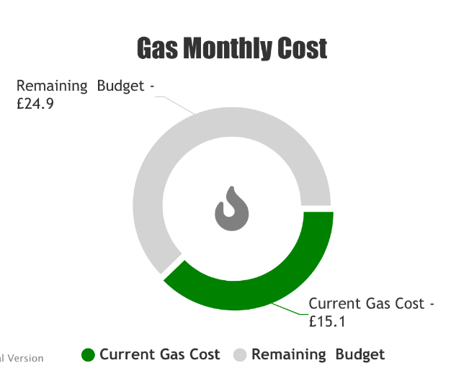

**Fig 4.1 showing a doughnut chart used in the website**

**Color choice explanation:**

When the total cost is below 50% of the set budget the segment of the chart representing the Total Cost will be displayed with a green color; green is the color of nature. It symbolizes growth, harmony and it has strong emotional correspondence with safety.

When the total cost is between 50% and 80% the segment will be represented with a yellow color (gold in our case for a good contrast with the white background). Yellow is a color which suggest impatient, precaution and warning. It will help the user understand that they should keep an eye on the consumption.

Finally, when the budget is over 80%, the color we have chosen is a bright red. The red color suggests error, danger, and warning. In our case it allows the user to understand that the total cost has almost reached or surpassed the set budget.

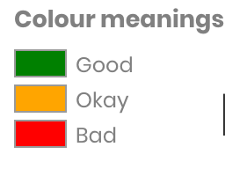

**Fig 4.2 showing what the colors mean in the chart**

One step at a time was taken when making the chart. When the Current cost is higher than the Budget, the grey segment will now be called ‘Overspent Budget’ which its size will keep increasing the more the user is overspending. This is shown in figure 4.3.

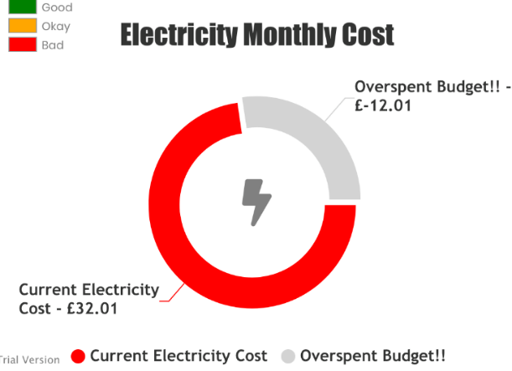

**Fig 4.3 showing the electricity chart for a customer who overspent**

The user is allowed to update his budget at any time. The main idea behind all this Is to notify them through an email or a text message when they reach the red zone (over 80%) and allow them to either reconsider their consumption or set a higher budget.

**Code Explanation:**

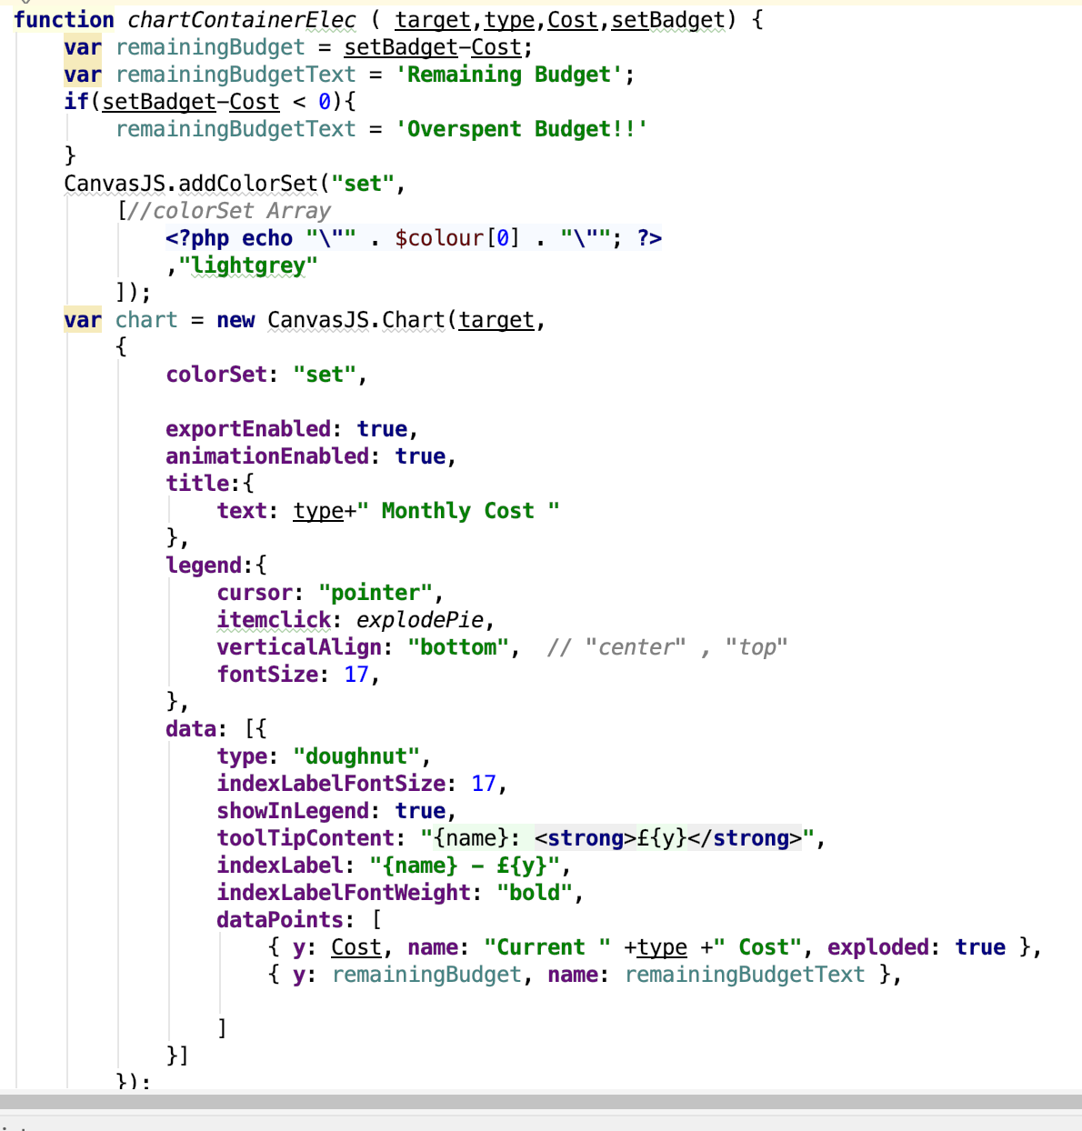

**Fig 4.4 showing code from chartscript.phtml**

As mentioned, before, CanvasJS doughnut charts was used.

The first step during implementation was to interact with their online demo on their website to get familiar with their code and try to make the code our own. That means, being able to display exactly the data needed for the user to see and in a specified way.

Thanks to the detailed documentation on their website, it was very easy understand how to interact with the code. The chart is completely customizable thanks to the options offered by their library; the font-size could be easily changed, which elements to show, where and what text to show and so on.

Finally, once the chart was customized on our preference, the only thing left to do was replace the hard-coded value in the function with data retrieved on real time.

The function was altered so that it would take 4 different parameters:

1. Target -> The HTML element tag ID name used to draw the chart.
2. Type -> Gas or Electricity
3. Cost -> Current cost given us by retrieving the current month consumption through the API and the totalCost() function.
4. SetBudget -> Budget retrieved from database

## Functions (Adeel Ahmed)

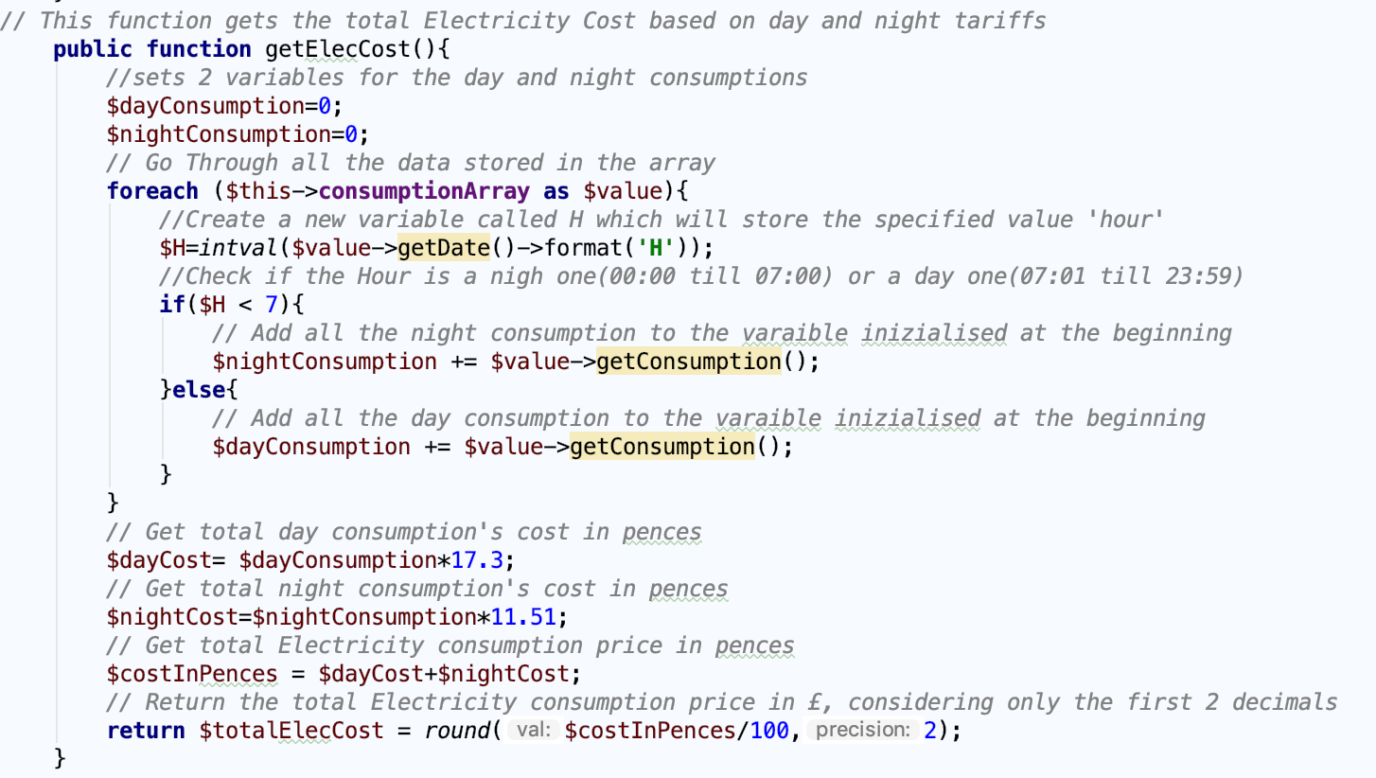

**Fig 4.5 showing code from ConsumptionDataSet.php class**

The function in figure 4.5 helps find the total cost of the electricity consumption.

There was a small problem when implementing this function. Electricity tariffs are divided into two parts: day and night, and they both have different price. Therefore, it was not accurate to use the same tariff for every kilowatts par hour (kWh).

Two local variables were created: $dayConsumption and $nightConsumption. Both set to zero (0).

Loop through the array and for each of the values do:

* Create a local variable called $H which stores the value’s hour time.
* Check if the H is smaller than 7: if it is, add the consumption to the night consumption.
* Else, add it to the day consumption.

(We assumed that the night tariffs go from midnight till 7am and the day one for the rest of the day)

Once that was over, the next steps in the code was:

* Multiply the day consumption by 17.3 pence (tariff chosen).
* Multiply the night consumption by 11.51 pence (tariff chosen).
* Add the 2 total cost together and return the total amountt in pounds.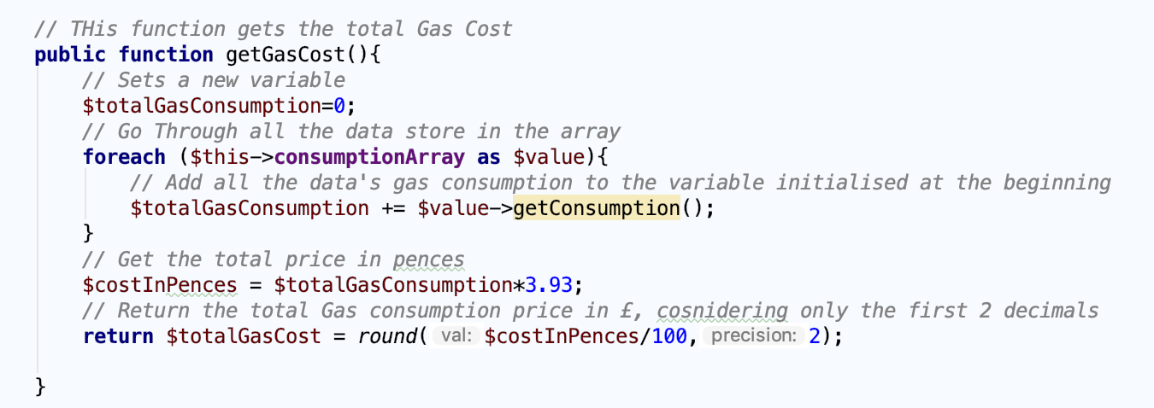

**Fig 4.6 showing code from ConsumptionDataSet.php class**

The function in figure 4.6 helps find the total cost of the gas consumption.

Luckily, the gas tariff is the same all day, no night and no day tariff. Therefore, it simply follows the same procedure of the function in figure 4.5 which loops through the array and add together the consumption for each value and finally multiply this total consumption by 3.93 pence (tariff chosen) and return the total cost in pounds.

## Database implementation (Omar Saleh)

the code below is taken from the “BudgetDb.php” file.

**public function insert**($data) {

if(!$this→**checkIfBudgetExists**($data["email"])){

$query = $this->conn->prepare("INSERT INTO budget(gasPrice,electricityPrice,email,date) VALUES(?,?,?,?)");

$query->bindParam(1,$data["gasPrice"]);

$query->bindParam(2,$data["electricityPrice"]);

$query->bindParam(3,$data["email"]);

$query->bindParam(4,$data["date"]);

$query->execute();

**} else {**

**$this->updateBudget($data);**

**}**

}

The first line of this method is an if statement and a call to the method to checkIfBudgetExists. The if statement checks if there is a budget in the database set by this user, if there is not a budget set, then the new budget is inserted in the database, else the old budget in the database is updated.

public function **checkIfBudgetExists**($email){

$query = $this->conn->prepare("SELECT * FROM budget WHERE email = ?");

$query->bindParam(1,$email);

$query->execute();

$row = $query->fetch();

if($row["date"] != null){

return true;

}

return false;

}

The method above takes the parameter $email and checks if there is a match in the database. If there is a match or if there is data that belongs to the $email parameter, then the methods returns true and false otherwise.

public function getBudget($email){

$query = $this->conn->prepare("SELECT * FROM budget WHERE email = ?");

$query->bindParam(1,$email);

$query->execute();

while($row = $query->fetch()){

return $row;

}

}

The getBudget method returns the budget details of a specified user, the parameter $email is used to search the database for the budget details.

## Home page design and implementation (Haashim Alvi)

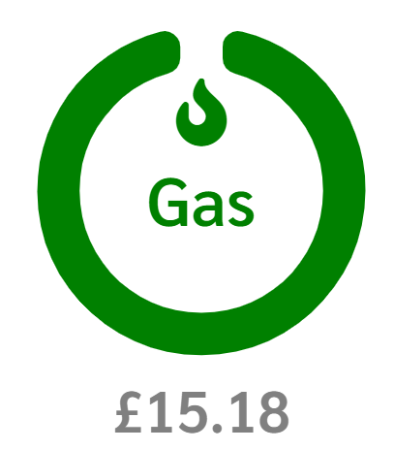Researched was done on what current features and designs smart meters have and what features consumers want in them. The circular design was chosen with the cost underneath and the color changing feature based on the budget.

**Fig 5.1 showing the circular design from the main page of the website**

The high contrast feature was also implemented on the index page. This feature inverts the colors used on the page for color blind people.

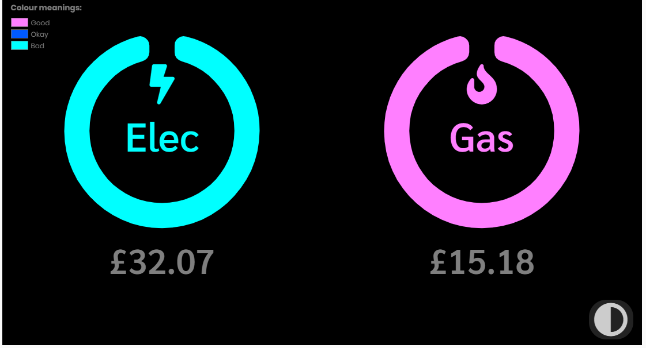

**Fig 5.2 showing high contrast mode in the website**

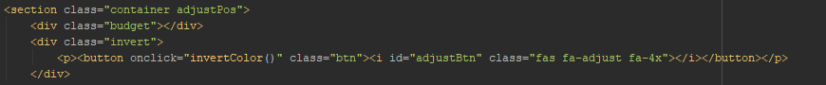

**Fig 5.3 showing code from index.phtml**

final thing that was done was to make the website live. The link to the website is <http://smartmeter.hopto.org>.

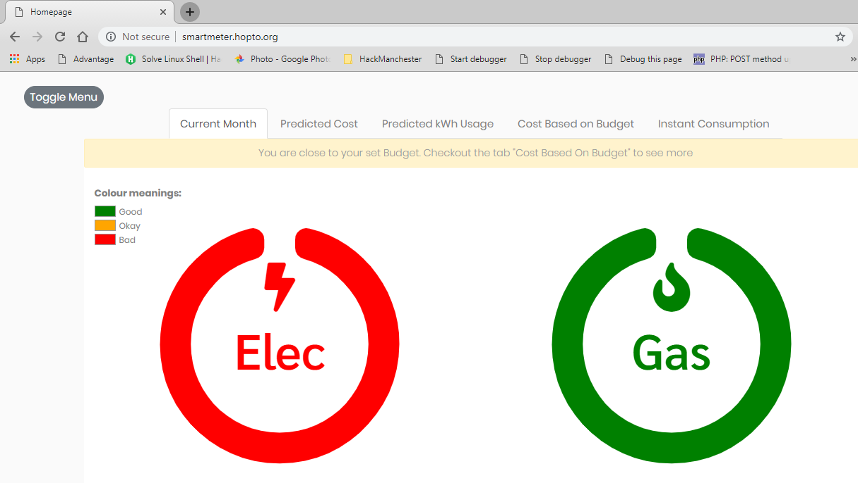

**Fig 5.3 showing the website live (www.smartmeter.hopto.org)**

# Details of the solution testing and evaluation

## SPRINT 1 (08/01/19 - 11/01/19)

### Testing Methodology

During the development of the project, each member of the team was responsible for executing Unit Testing on every piece of code they were working on. In that way, the testing process sped up, while also assuring a good quality of code.

Nonetheless, at the start of the first sprint, a person was chosen that would be responsible for repeating every Unit Testing and executing Acceptance Testing before every demo.

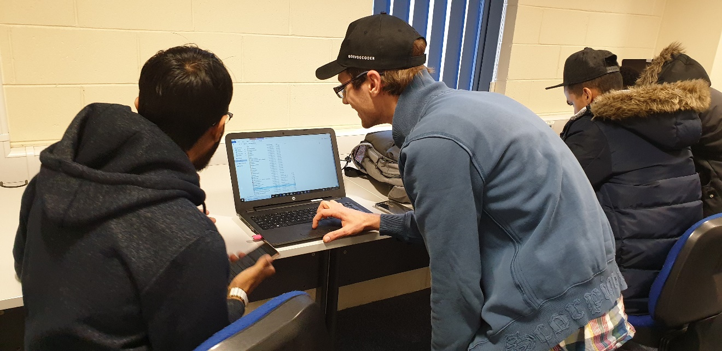

### Unit Testing

During sprint 1, Unit Testing was executed for the following features and scopes:

* Consistency of data from the EnergyHive API
* Connection with EnergyHive API in PHP
* Consumption Data Set
* Consumption Data Type
* Monthly total usage and cost
* Consistency of data from Weather API
* Controllers and Views generation
* Navbar

The following problems were underlined by testing:

* The presence of many unused lines of CSS and JS code caused issues with the design of the front-end not behaving as expected

### Acceptance Testing

By the client’s request, the following requirement could be identified:

* Display Hourly consumption for Gas and Electricity
* Display Instantaneous consumption for Gas and Electricity
* Compare consumption with previous day
* Predict consumption based on Weather

An Acceptance Test for each requirement was executed with the following results:

* The hourly consumption is only shown as a conceptual demo. The appearance is acceptable, but no real information is shown
* There is no page to show instantaneous consumption
* There is no page to compare consumption
* There is no page to predict consumption

The Acceptance Testing proven the project to be in an early stage of development. While a good part of the back-end is present, the product is still unusable.

## SPRINT 2 (11/01/19 - 14/01/19)

### Testing Methodology

The same testing methodology as the previous sprint was used.

### Unit Testing

During sprint 2, all Unit Testing executed during sprint 1 ware repeated, further Unit Testing was executed for the following features and scopes:

* Consistency of Machine Learning algorithms to predict future consumption
* Colour inversion for Colour-blinds
* Database connection for Budget
* Consumption charts
* Comparison Page
* Cost Based on Budget pie chart

No relevant problems were underlined by testing.

### Acceptance Testing

The client’s requirements were the same as previous sprint.

An Acceptance Test for each requirement was executed with the following results:

* The hourly consumption is properly shown in an interesting and useful way. The data is real and updated. The user is given the option to choose a different range besides hourly.
* There is no page to showing instantaneous consumption.
* The comparison page shows today consumption compared with yesterday consumption. The data is real and updated. The design proves to be functional, but the way the data is shown could be confusing for some users
* There is no page to predict consumption.

The Acceptance Testing proves that the project is proceeding at a good pace. Two out of the four requirement were satisfied. However, the front end for the comparison page will need refactoring.

## SPRINT 3 (14/01/19 - 18/01/19)

### Testing Methodology

The same testing methodology as previous sprints was used.

### Unit Testing

During sprint 3 all Unit Testing executed during sprint 1 and 2 were repeated, further Unit Testing was executed for the following features and scopes:

* Budget Data type
* Budget Data Set
* Speed gauge tor Instantaneous Consumption
* Comparison charts
* Http Getters
* Prediction Data type
* Prediction Charts
* Set Budget page
* Budget warning

No relevant problems were underlined by testing.

### Acceptance Testing

The client requirements were the same as previous sprint expect on regard of the comparison page:

* Compare consumption with previous day and allow the user to compare other time ranges too. Shows data in a graphical way as just numbers might be confusing.

An Acceptance Test for each requirement was executed with the following results:

* The hourly consumption is properly shown in an interesting and useful way. The data is real and updated. The user is given the option to choose a different range besides hourly.
* The instantaneous consumption is shown in an intuitive and useful way. The data is real and updated.
* The comparison page is properly implemented. The data is real and updated. The data is shown in a graphical and useful way. The user is given the option to compare other time ranges besides yesterday with today.
* The prediction page is properly implemented. The data is real and updated. The predictions are shown in an interesting and useful manner. The user is given the option to visualize the prediction based on cost or kWh usage.

The Acceptance Testing proves that the project satisfies all client requirements.

# Conclusions, summary and evaluation of the achieved results

In the beginning of the challenge group 2 received the project brief and it explained that the client wanted a platform that would display energy consumption data from a smart meter. This will allow the users to view how much energy they are using. The goal was to display the energy in creative and easy to understand ways for the user.

In this project, the group was given access to a live API system which provides energy consumption data from the smart meters in the lab (Joules house).

The main requirements explained that the user should be able to view the hourly and instantaneous electricity and gas consumption, comparing the current to the previous days consumption and use of weather forecasting to predict higher or lower consumption depending on next day’s weather conditions.

After the briefing, the team discussed how they should continue and what the areas were that the client was most excited about since this would be what the group would focus on. The team agreed that the front end was the biggest task they had to face since the main goal was to display the data to the user in an interesting way.

Haashim stated that he had done some front-end projects and jQuery would be a great front-end library to use. jQuery provides many dynamic charts and features that could help present the data in a unique way. Reflecting on jQuery, the team feels that it helped a lot, allowed them to be more creative and opened many more possibilities to display the data.

Omar were tasked to create a set budget page which would allow the user to set budget for the gas and electricity for the current month. This budget would be stored in the database. The data stored in the database is used to calculate the cost so Kumail and Abdi-rahman worked with Omar to get it done. Reflecting on this, the group thinks that the adding a set budget helps the user manage their energy consumption in a simple yet more efficient manner and was a great additional feature to add.

Davide and Abdi-rahman suggested that the group should use git to organize the code and allow the team members to pull the latest updates made. This would allow for a better management of the code and would make the code more maintainable and easier to track. Reflecting on git the group believes that it helped them a lot with the project, it also helped speed up the development as we had all the version so when something went wrong, the old version could be easily retrieved as most branches remained and not deleted.

During the coding phase Adeel and Davide were working as testers in which they tested both the front-end and back end. Therefore, their main task was understanding how functions works so if there is problem, they could assign solve it and to avoid any delays.

Also, during the coding phase Abdi-rahman started working on documenting the process for the report and checking if the team is on the correct path, and if there were going to be any delays.

Reflecting back on this the group thinks that it would have been better if they started breaking down the process into smaller pieces to help write the report, so each person can start working on their part of the report. The team used many platforms to document the process such as Trello, WhatsApp, and the University email.

Abdi-rahman as the scrum master organized the group daily, stayed in contact with the client and Dr. Julian Bass to discuss many different issues of the project, he kept the team spirit going during each sprint, and made sure that the team achieved what the client needed. Reflecting on this the team agrees that Abdi-rahman did a fantastic job as the scrum master.

The group is very positive with the results. The group has organized themselves well, have a well-documented code, a working prototype that is polished, and one that the client has tested and approved of.

## Improvements:

During the development of the project, group 2 faced their fair share of hurdles. Given the short time the group had, some of these were resolved and some of these were left to be worked on after the Hack Camp if needed. The improvements to be made by group 2 can be split into the following sections:

### Technical Improvements:

* Sanitize the training data more to achieve a more accurate data set for prediction.
* Make the chart elements on the page more user friendly and responsive.
* Collect more data for the training set.
* Transform the prediction class into a class which adds every new entry into the training set and so can predict new unseen instances (True Machine Learning).
* Different types of colour blindness need to be added as a filter to the website.
* The location of the smart meter needs to be retrieved automatically from the IP of the user. This has been implemented but not been made use of since the system took too long to make live.
* Implement mailing system to alert the user if they have gone over budget. This has been replaced by an alert in the UI due to the short time.
* Custom comparisons made on specific dates need to be implemented but shortage of time did not allow for that to be done. Essential comparisons (days, months, years) were however implemented.
* Side sub menu under a single charts tab needs to be implemented to limit the options appearing to the user in the menu.

### Process Improvements:

* Consistent use of Trello.
* Group members arriving on time.
* Consistently documenting testing done on the product.
* Group members not productive during work hours.
* No change process in place and so drastic changes to the code would go through without the authorization of all the group members.
* Commenting the code at the time it was written rather than at a later date.
* Better allocation of tasks. (It was noticed that there were times when certain group members did not have any task to do).

# References

(2018). Retrieved from https://www.lucidchart.com/pages/uml-use-case-diagram

*Bar Charts*. (n.d.). Retrieved from Google Charts: https://developers.google.com/chart/interactive/docs/gallery/barchart

Bass, D. J. (n.d.). *BlackBoard*. Retrieved from blackboard.salford: https://blackboard.salford.ac.uk/webapps/blackboard/execute/content/file?cmd=view&content_id=_3345760_1&course_id=_95570_1

Bass, J. (n.d.). *blackboard*. Retrieved from blackboard.salford: https://blackboard.salford.ac.uk/webapps/blackboard/execute/content/file?cmd=view&content_id=_3345756_1&course_id=_95570_1

Bass, J. (n.d.). *Salford*. Retrieved from Salford: https://blackboard.salford.ac.uk/bbcswebdav/pid-3342234-dt-content-rid-7374430_1/courses/SG-G400-20081-34129-19/Lect5%20SCRUM%2020180913.pdf

Bell, D. (2004, 09 15). *The class diagram*. Retrieved from ibm: https://www.ibm.com/developerworks/rational/library/content/RationalEdge/sep04/bell/index.html

*Color contrast*. (2016). Retrieved from designworkplan: http://designworkplan.com/design/signage-and-color-contrast.htm

*Colour vision deficiency (colour blindness)*. (2016, 04 25). Retrieved from NHS: https://www.nhs.uk/conditions/colour-vision-deficiency/#types-and-symptoms-of-colour-vision-deficiency

Drumm, D. I. (n.d.). *BlackBoard*. Retrieved from blackboard.salford: https://blackboard.salford.ac.uk/webapps/blackboard/execute/content/file?cmd=view&content_id=_3318895_1&course_id=_97716_1

Focus, C. (n.d.). *ridc*. Retrieved from https://www.ridc.org.uk/sites/default/files/documents/pdfs/research-consultancy/smart-meter-in-home-display-design-usability-good-practice-guidance.pdf

Kobos, B. (n.d.). *gauge.js*. Retrieved from gauge.js: http://bernii.github.io/gauge.js/

*MVC architecture*. (2018, 6 8). Retrieved from MDN Web Docs: https://developer.mozilla.org/en-US/docs/Web/Apps/Fundamentals/Modern_web_app_architecture/MVC_architecture

tableau. (2018, 8). *Share of households with internet access in the United Kingdom (UK) from 1998 to 2018*. Retrieved from statista: https://www.statista.com/statistics/275999/household-internet-penetration-in-great-britain/

*Total Color Blindness*. (n.d.). Retrieved from Color Blindness: http://www.colour-blindness.com/variations/total/

Kondas, A. (2019). *KNearestNeighbors - PHP-ML - Machine Learning library for PHP*. [online] Php-ml.readthedocs.io. Available at: https://php-ml.readthedocs.io/en/latest/machine-learning/classification/k-nearest-neighbors/ [Accessed 21 Jan. 2019].

Boggiano, J. (2019). *Packagist*. [online] Packagist.org. Available at: https://packagist.org/ [Accessed 21 Jan. 2019].

ThePHPGroup (2019). *PHP: cURL - Manual*. [online] Php.net. Available at: http://php.net/manual/en/book.curl.php [Accessed 21 Jan. 2019].

Mlsdev.com. (2019). *Beginners tutorial for understanding restful API's*. [online] Available at: https://mlsdev.com/blog/81-a-beginner-s-tutorial-for-understanding-restful-api [Accessed 21 Jan. 2019].

Eisen, C. (2019). *Energyhive · Apiary*. [online] Energyhiveapi.docs.apiary.io. Available at: https://energyhiveapi.docs.apiary.io/# [Accessed 21 Jan. 2019].

Openweathermap.org. (2019). *Weather API - OpenWeatherMap*. [online] Available at: https://openweathermap.org/api [Accessed 21 Jan. 2019].

Ipstack.com. (2019). *API Documentation - ipstack*. [online] Available at: https://ipstack.com/documentation [Accessed 21 Jan. 2019].

Brownlee, J. (2019). *How To Use Regression Machine Learning Algorithms in Weka*. [online] Machine Learning Mastery. Available at: https://machinelearningmastery.com/use-regression-machine-learning-algorithms-weka/ [Accessed 21 Jan. 2019].

Bryant, C. (2019). *Instance-Based (or Lazy) Learning: k-Nearest Neighbour*.

# Appendices

## Daily scrum stand-up meetings

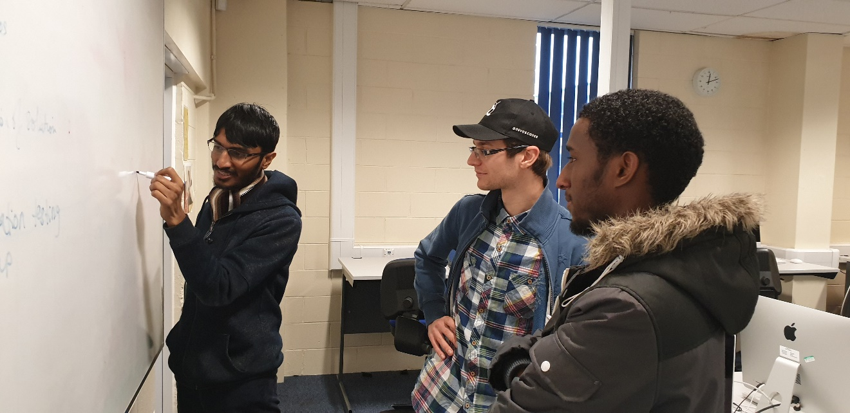

### Daily Stand-up meeting - Tuesday 08/01/2019 at 11:00 am

**Attendees:**

**Adeel, Davide, Kumail, Haashim, Abdi, Omar**

*What did everyone do yesterday?*

* This is our first meeting.

*What is everyone doing today?*

* All: Skills reflection for each member of the team
* All: Each member’s role within the group
* Kumail, Adeel, Davide: Figure out how to access the data using the API
* Haashim: Set up Git-hub
* All: Question for the client to clarify some requirements
* Haashim: Setting up Trello
* All: Rules of Conduct
* Abdi-rahman: Product Backlog

*Any problems?*

* No Problems so far in the project.

### Daily Stand-up meeting - Wednesday 09/01/2019 at 11:00 am

***Attendees:***

***Adeel, Davide, Kumail, Haashim, Abdi, Omar***

*What did everyone do yesterday?*

* Adeel: Figured out how to access the data from the API that was given to us by using the website called postman. This was done after doing some research on restful API and how they are used.
* Davide: Figured out how to change the information on the URL to see different types of data. So, we can view information about minute, hour, day, week, month, and year.
* Kumail: Has converted the data to readable and meaningful information in order for the viewer to read it. Also managed to use php in order to access the API and view the information on a web page.
* Haashim: Worked on git and GitHub in order for us to share work more easily. It will be done by today.
* Abdi & Omar: Built a product backlog filled with user stories that define features of the requirements of the project.

*What is everyone doing today?*

* Omar: Work on stand-up write up
* Kumail: Retrieve data, work on the MVC template, discussed about the class models and what information is needed by the front-end team.
* Abdi: Work on the report, update the back log, email teacher on what he needs for day 2, help with the class planning.
* Haashim: Research the front-end design and work on setting git/GitHub for everyone.
* Davide: Research usability and plan the design of the pages.
* Adeel: Work on the data and MVC template.

*Any problems?*

* Setting up git hub is difficult and might need more time.

### Daily Stand-up meeting – Thursday 10/01/2019 at 11:00 am

**Attendees:**

**Adeel, Davide, Kumail, Haashim, Abdi, Omar**

*What did everyone do yesterday?*

* Adeel: Worked on retrieving data and MVC Template. Discussed on class models with Kumail and Abdi. Talked with the front-end team regarding the data they will require for the display.
* Davide: Research on usability. Planned the design of the website with Haashim.
* Kumail: Discussed on class models with Adeel and Abdi. Talked with the front-end team regarding the data they will require for the display.
* Haashim: Setup Git-Hub for the whole group. Planned the design of the website with Davide.
* Abdi: Discussed on class models with Adeel and Kumail. Worked on the report. Backlog updated.
* Omar: Stand-ups notes.

*What is everyone doing today?*

* Adeel: Back-end -> Create functions to retrieve data from PHP and calculate their total costs.
* Davide: Front-end -> Multiple tabs for the homepage
* Kumail: Back-end -> Retrieve Weather Data using API, Improve MVC template
* Haashim: Front-end -> Left-side Navbar menu
* Abdi: Back-end -> work with Kumail to retrieve the data for the weather data set. Update report.
* Omar: Front-end -> Set Budget page

*Any problems?*

* Retrieving Weather Dataset using an API will take longer than expected
* Navbar issues with layout

### Daily Stand-up meeting – Friday 11/01/2019 at 11:00 am

**Attendees:**

**Adeel, Davide, Kumail, Haashim, Abdi, Omar**

*What did everyone do yesterday?*

* Adeel: Back-end -> Encapsulated and working functions for: Retrieving Gas and Electricity Consumption, Retrieve the full cost for both of Gas and Electricity. Stand Up notes.
* Davide: Front-end -> Home Page working with multiple tabs and prototype design
* Kumail: Back-end -> MVC structure improved and weather dataset successfully retrieved
* Haashim: Navbar but still need adjustment
* Abdi: Back-end -> work with Kumail to retrieve the data for the weather data set. Update report.

*What is everyone doing today?*

* Adeel: Front-End -> Help front-end team to pick up the pace and redo the whole HTML CSS structure and create Charts
* Davide: Work on the prototype design to be ready for the demo
* Kumail: Work on Machine Learning and apply algorithm to predict the future consumption
* Haashim: Update Report and colour-blind feature
* Abdi: Work on setting the Database with Omar
* Omar: Work on set a Database with Abdi

*Any problems?*

* Applying the right algorithm with the lowest rate of error will require more data for training and testing.

### Daily Stand-up meeting – Monday 14/01/2019 at 11:00 am

**Attendees:**

**Adeel, Davide, Kumail, Haashim, Abdi, Omar**

*What did everyone do yesterday?*

* Adeel: Front-End - > Refactored the whole HTML and CSS structure with the navbar fully working
* Davide: Worked on the prototype for the Demo and start working on charts with Adeel
* Kumail: Chosen the K-nn algorithm
* Haashim: Colour blind feature working but still need improvements
* Abdi: Database created
* Omar: Database created

*What is everyone doing today?*

* Adeel: Front-end and Back-end -> New Feature, Cost based on Budget dynamic chart
* Davide: Consumption Charts
* Kumail: Refined the machine learning back end with the chosen algorithm
* Haashim: Apply research on colour blind to the back-end and front-end
* Abdi: Update Report and work on the comparison page
* Omar: Connect Database to the set budget page

*Any problems?*

* Comparison page did not meet the client expectation. Therefore, it needs more work.

### Daily Stand-up meeting - Tuesday 15/01/2019 at 11:00 am

**Attendees:**

**Adeel, Davide, Kumail, Haashim, Abdi, Omar**

*What did everyone do yesterday?*

* Adeel: Completed Cost based on budget doughnut chart
* Davide: Consumption chart completed for daily option
* Kumail: Successfully implemented the algorithm
* Haashim: Colour blind feature implemented
* Abdi: Comparison page done but not met client expectation.
* Omar: Database inserting and retrieving data successfully

*What is everyone doing today?*

* Adeel: Back-end: Connect budget retrieved from database to the website charts/features
* Davide: Code Refactoring, CSS improvements, JS improvements
* Kumail: Back-End -> Prediction page
* Haashim: Speedometer
* Abdi: Report Update and more research regarding usability and improve the comparison page
* Omar: Help Kumail with the prediction page

*Any problems?*

* A lot of un-used CSS and JavaScript file in the project. Need a big refactoring of the whole code

### Daily Stand-up meeting – Wednesday 16/01/2019 at 11:00 am

**Attendees:**

**Adeel, Davide, Kumail, Haashim, Abdi, Omar**

*What did everyone do yesterday?*

* Adeel: Database connected with the website and data successfully retrieved where needed
* Davide: Code cleaned, a lot of excess files been removed
* Kumail: Back-end -> Prediction page
* Haashim: researched speedometer
* Abdi: Use of charts for comparison and worked on retrieving the data on the back-end
* Omar: Prediction page completed

*What is everyone doing today?*

* Adeel: Work on the speedometer with Davide, fix some CSS issues, and only view cost based on budget feature when budget has been set in the database
* Davide: Work on the speedometer with Adeel, extra features for the comparison charts
* Kumail: Fix Prediction page, try to make the website live.
* Haashim: High Contrast Option, Side Menu fixes
* Abdi: Validation on budget, make consumption calculations constant
* Omar: Add date feature in set budget page

*Any problems?*

* Hosting the website live is harder than we expected. We will need to come back to it and rethink about the email feature.

### Daily Stand-up meeting - Thursday 17/01/2019 at 11:00 am

**Attendees:**

**Adeel, Davide, Kumail, Haashim, Abdi, Omar**

*What did everyone do yesterday?*

* Adeel: Speedometer completed, CSS issues fixed, cost based on budget only viewing when budget is set.
* Davide: Speedometer completed. And instantaneous consumption retrieved. Comparison Charts completed.
* Kumail: Prediction page fixed.
* Haashim: Issues fixed.
* Abdi: Validations and consumption calculations completed.
* Omar: extra feature added to the set Budget page.

*What is everyone doing today?*

* Adeel: Report -> Work on the stand-ups
* Davide: Front-end -> Comparison Charts and refactoring charts back -end code (HTTP GET)
* Kumail: Report ->Class Diagram, Data Mining process description
* Haashim: Make the website live
* Abdi: Report -> Pair Programming, Customer Demo (Sprint 1 & Sprint 2)
* Omar: Report -> Motivation

*Any problems?*

* We fall behind with the report and the power point presentation. We decided to have a CODE FREEZE and not add any more features and focus on the report for the remaining part.

### Last Daily Stand-up meeting – Friday 18/01/2019 at 11:00 am

**Attendees:**

**Adeel, Davide, Kumail, Haashim, Abdi, Omar**

*What did everyone do yesterday?*

* Adeel: Report -> Stand-up for every day added to the report
* Davide: Front-end -> Comparison charts and refactoring completed
* Kumail: Report -> Class Diagram and Data Mining process completed and added to report
* Haashim: Website successfully hosted live
* Abdi: Report ->Sprint 1 and Sprint 2 completed and added to the report
* Omar: Report -> Motivation added to the report

*What is everyone doing today?*

* Adeel: Report -> Sprint 3
* Davide: Testing before demo. Fix bugs.
* Kumail: Report -> Implementation testing
* Haashim: Report -> Add stand up/demos photo, Trello state and colour-blind research
* Abdi: Report -> Go over the whole report
* Omar: Report -> Work on Conclusion

*Any problems?*

* Overall, no major problems. We set some deadlines for every task and we successfully met them without big delays. The only concern might be the Power Point presentation which we decided to leave as last, but we will work on it as a team during the span of time that goes from the CODE FREEZE and the presentation.